概一一阶爱学习课中测

Name: Score:

**一．单选。**

1.– Is this ________ bag, Jimmy?

– Yes, it is my bag.

A. my B. your C. his D. her

2. Is it a German car or an American car?

A. Yes, it is. B. No, it isn’t C. It is a German car.

3. This is my sister. ___ name is Lucy. That is ____car.

A. She; she B. She; her

C. Her; she D. Her; her

4. My father is a ________.

A. housewife B. Italian C. policeman D. Jason

5. – Good morning, Mary.

– ________, Mrs. Green.

A. Excuse me B. Good afternoon

C. Good morning D. Pardon

二．选词填空

am is are

1.He ______ (be ) an engineer.

2. _______(be) you a keyboard operator.

3.She _______(be) not French.

4.I ___(be) a new student.

5.What ___(be) your job?

a an

6.Nancy is______teacher. 7.This is______Japanese car.

8.It is______American car. 9.She is______Chinese girl.

10.I am______new student.

三．适当形式填空a an he she it

1.This is Nancy.______is Chinese.

2.Jason is______ teacher.

3.This is his car.______ is______Japanese car.

4.Lucy is______ American student.

5.This is John.______ is German.

四．改写句子

1，I am a teacher.(改为一般疑问句并做肯定回答）

___________________________

1. This is my school.(改为一般疑问句并做否定回答） ________________________

3.These are her things. (变否定句)

___________________________

4. His name is Jason. (对划线部分提问)

_______________ _______________ his name?

5. He’s a milkman. (对划线部分提问)

_______________ his _______________?

五．应答配对

（ ）Nice to meet you. A.I’m an engineer.

（ ）What’s your name? B. I’m an Italian.

（ ）What make is it? C. Nice to meet you.

（ ）What nationality are you? D.I’m Sophie.

（ ）What’s your job? E.It’s a Peugeot.

六．情景交际

Betty: Good afternoon, Mary. Mary: 1. ________

Betty: Is that your car? Mary: Pardon?

Betty: 2. ________ Mary: No, it isn’t. My car is blue.

Betty: Is it your brother’s? Mary: No, it isn’t. 3. ________

Betty: 4. ________ Mary: It’s my father’s car.

Betty: It is a nice car. Mary: 5________ .

A. Whose car is that? B. Is that your car?

C. Thank you. D. Good afternoon, Betty.

E. His car is white.

七．阅读理解

Cathy likes T­shirts very much. She has many T­shirts. She likes purple, red and black. Red is her favourite colour. Her brother Bob likes to wear trousers. And blue is his favourite colour. Look! Cathy is wearing a purple T-­shirt and Bob is wearing blue trousers.

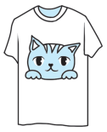(　　)1. Cathy likes ________ very much.

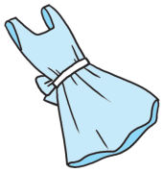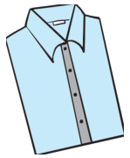A. B. C.

(　　)2. ________ is Cathy's favourite colour.

A. Yellow B. Blue C. Red

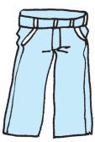(　　)3. Bob likes to wear________.

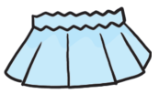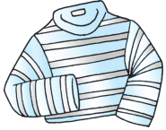A. B. C.

(　　)4. Bob is wearing ______ trousers.

A. yellow B. blue C. green