**大 桥 外 语 调 研 考 试**

**新概念一Unit 1 (小学)**

# (时间:60 分钟 满分:100 分)

**学校: _ 学生姓名: 任课教师: _ 时段：_**

|  |  |  |  |  |  |  |  |  |  |  |  |  |
| --- | --- | --- | --- | --- | --- | --- | --- | --- | --- | --- | --- | --- |
| **题号** | **听力部分(25 分)** | | | | | **笔试部分(75 分)** | | | | | | **总分** |
| **Ⅰ** | **Ⅱ** | **Ⅲ** | **Ⅳ** | **Ⅴ** | **Ⅰ** | **Ⅱ** | **Ⅲ** | **Ⅳ** | **Ⅴ** | **Ⅵ** |
| **得**  **分** |  |  |  |  |  |  |  |  |  |  |  |  |

**听力部分(25 分)**

得分

**Ⅰ. 听音，选出你所听到的单词。(读一遍)(5 分)**

( ) 1. A. my B. me C. five

( ) 2. A. there B. here C. where

( ) 3. A. at B. am C. are

( ) 4. A. you B. your C. young

( ) 5. A. cat B. catch C. coat

# Ⅱ. 根据你所听到的句子，选择与其相符的图片。(读两遍)(5 分)

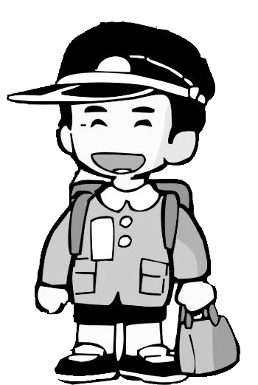

得分

A. B. C.

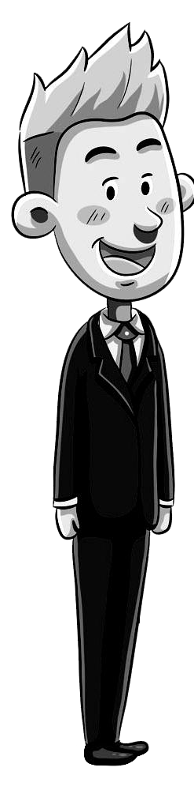

D. E.

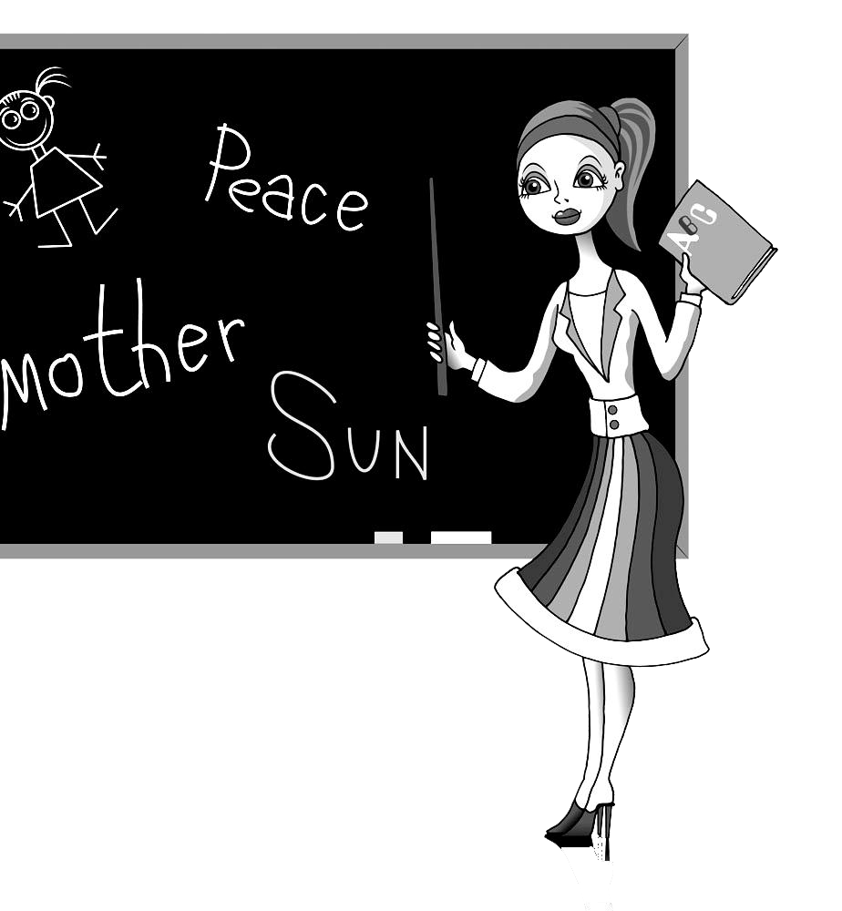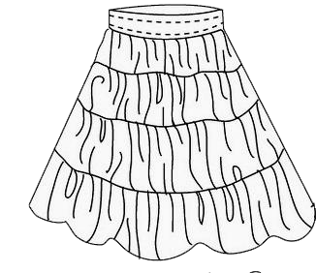

# Ⅲ. 根据你所听到的句子，选择合适的答语。(读两遍)( 5 分)

|  |  |  |
| --- | --- | --- |
| ( ) 11. A. Yes, she is. | B. Yes, it isn’t. | C. Yes, it is. |
| ( ) 12. A. He is cold. | B. He’s a policeman. | C. He is Chinese. |
| ( ) 13. A. I’m sorry. | B. Nice to meet you, too. | C. Good morning. |
| ( ) 14. A. It’s his pen. | B. He is a student. | C. He’s very well. |
| ( ) 15. A. It’s Bob’s. | B. It’s black. | C. Goodbye. |

**Ⅳ. 根据你所听到的对话内容，选择正确答案。(读两遍)( 5 分)**

得分

得分

( ) 16. What is Amy’s?

A. The handbag. B. The blouse. C. The coat. ( ) 17. The umbrella is .

A. Mr. Green’s. B. old. C. new. ( ) 18. This is a coat.

A. clean B. Italian C. French ( ) 19. What’s the woman’s job?

A. Mechanic. B. Keyboard operator. C. Policewoman. ( ) 20. Whose bike is this?

A. The boy’s. B. The girl’s. C. Lin Hai’s.

得分

# Ⅴ. 根据你所听到的短文内容，判断正误，正确写“T”， 错误写“F”。 (读两遍)( 5 分)

( ) 21. My good friend’s name is Lucy.

( ) 22. We are in Class Four, Grade One. ( ) 23. Lucy’s brother is a teacher.

( ) 24. Tom is a short boy.

6.

7.

8.

9.

10.

( ) 25. We are all good friends.

# 笔试部分 .

**一．选择最恰当的答案。**

# ( ) 26. What is this? 五.应答配对。

A.It’s a umbrella. B.It’s an umbrella. C. The coat. ( ) 41. What’s your job? A.He is Chinese.

( ) 27. ---Here is your shirt. --- very much. ( ) 42. What nationality is he? B. I am an engineer.

1. Good-bye B. Thank you C. Hello ( ) 43. What’s your name? A.It’s a Volvo

( ) 28. Good morning. ( ) 42. What make is it? B. I am Liming.

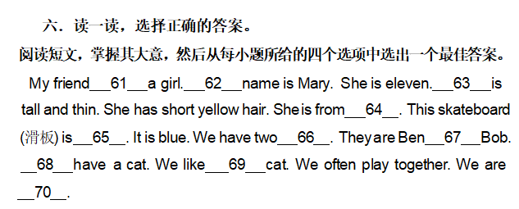A.Good morning. B. Good evening. C. Good night.

( ) 29. Is this a Chinese car or an English car ?

A.Yes ,it is. B. An English car .C. Thank you.

( ) 30. Thank you very much.

A. You are welcome. B. me,too. C. pardon?

**二．用括号内所给词的适当形式填空。**

1. Excuse (I). Is this your handbag?
2. Kelvin is (America).
3. I (be) a German student.

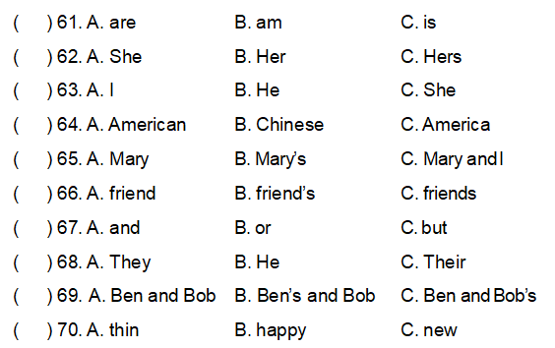**三．选词填空**

1. Sherry is (a/an) engineer.
2. This is (father/father’s) tie.

# 四．按要求改写句子，没空限填一次

31.She is my daughter. (改为一般疑问句)

_ _ _ your daughter?

32.I am an engineer. (对画线部分提问)

Is your _?

33.I am Chinese. (对划线部分提问)

are you?

1. much, you, thank, very (连词成句，标点已给出，注意大小写。)

.

1. Lisa’s, blue, is, pen (连词成句，标点已给出，注意大小写。