考辅三

I.听句子，选出句子中所包含的信息。（共5小题，每小题1分，计5分）

1.A.life B.wife C.leaf

2.A.9:15 B.8:55 C.9:05

3.A.put up B.picked up C.took up

4.A.Angela likes collecting postcards.

B.Angela likes collecting stamps.

C.Angela likes collecting stamps and postcards.

5.A.You should decide to learn English well

B.You should do nothing to learn English well .

C.You should try your best to learn English well.

Ⅱ听句子，选出该句的最佳答语。（共5小题，每小题分，计5分）

6.A.He is fine. B.He is running. C.He is a farmer.

7.A.All right. B.The same to you. C.Thank you all the same.

8.A.Good idea! B.I think so. C.OK,I will.

9.A.Sorry,I don't. B.Of course. C.It doesn't matter.

10.A.France. B.French. C.Next Monday.

Ⅱ.听对话和问题，选择正确答案。（共8小题，每小题1分，计8分）

1. How was the weather at first?

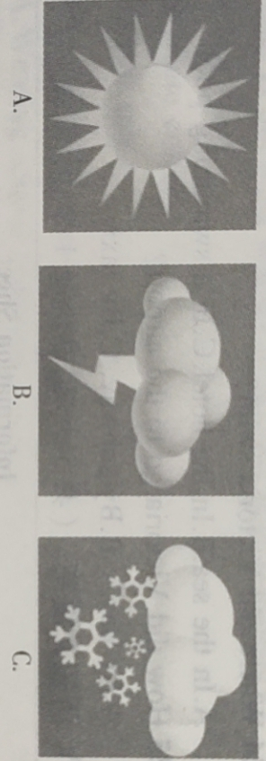

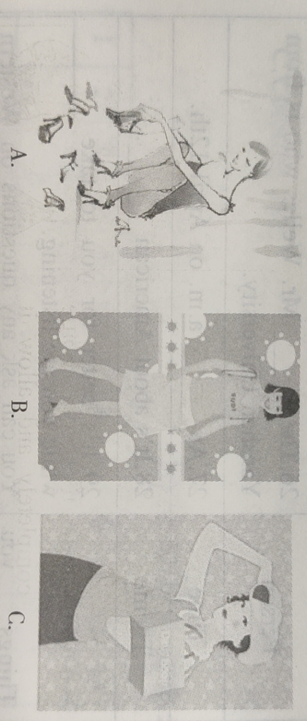12.What is the mother doing now?

13.What's the date today?

A.November 11. B.November 12. C.November 10.

14.Who got a job in Shanghai?

A.Lucy's sister. B.Lucy's brother. C.Lucy's father.

15 . When may Lucy go to Shanghai ?

A.This Saturday. B.Next Monday C.Next Saturday.

16.When will the baseball season start?

A.Next week. B.Next weekend. C.Next month.

17.What does the girl like best?

A.Baseball. B.Basketball. C.Volleyball.

18.How often does the girl swim?

A.Every day. B.Once a week. C.Three times a week.

IV.听短文和问题，选择正确答案。（共7小题，每小题1分，计7分）

19.When can we visit the museum on Saturday?

A.From 8:00 am to 6:00 pm

B.From 9:00 am to 7:00 pm C.From 7:00 am to 6:00 pm

20.What can we take into the museum?

A.Cellphones. B.Drink. C.Food.

21.Why shouldn't we touch the works in the museum?

A.People are enjoying the works quietly.

B. It may make them dirty or broken .

C.They are expensive

22 . What's Bruce's favorite hobby ?

A.Reading. B.Playing ping-pong C.Listening to music.

23.Which kind of music does Bruce like?

A.Classical music. B.Pop music. C.Country music.

24.When did Bruce and his friends set up their band?

A.At the age of 12. B.At the age of 13. C.At the age of 20.

25. How was their performance at the school's music festival?

A.It was successful. B.It was colorful. C.It was popular.

|  |
| --- |
| **Information Sheet**  **About the problem**  26.Wang Mei isn't good at___________.  **How to improve**  27.Listen to the teacher_________.  28.Take_________ in class .  29.Spend________time studying English.  30.Ask the teacher for___________. |

V.听短文填空。（共5小题，每小题1分，计5分）

VI.单项选择

31. Keep studying hard and you'll make great _______ sooner or later .

A.decision B.ability C.development D.progress

32.--Have you heard of the big fire that broke out in Guanghua Factory?

-Yes. Luckily, hundreds of firemen went there and ________the fire immediately.

A.take off B. put off C. take out D. put out

33. Be friendly, or you______ your friends.

A.lose B.lost C.have lost D.will lose

34.-We couldn't find you anywhere around 8:00 yesterday.

-I am sorry for it . My mother and I ______ on the square .

A.will dance B.danced C.were dancing D.are dancing

35.Mr . Green _ be in Beijing now . He has gone to America to see his daughter .

A. can't B.mustn't C.may not D.must

36.We really enjoyed the picnic yesterday _ it rained in the afternoon and some of us got wet .

A.when B.because C.though D.after

37. - Do you know the woman _______ is standing outside the classroom ?

-Yes. she is Tom's mother, my neighbor.

A.what B.which C.whose D.who

38 . I ______ a test and I'm waiting for the result .

A.will take B.took C.am taking D.take

39.To protect the environment in our country, many trees____every year.

A.are planting B.will plant C.are planted D.will be planted

40. They want to go on a trip by train tomorrow, but still can't decide___.

A.how they're going B.where they're going

C.why they're going D.when they're going

VII.完形填空（共10小题，每小题1分，共计10分）

One day, a hunter went hunting with his dog. He saw a rabbit running out of a bush not far in front and __41__ raised his gun to shoot. The rabbit was hurt. It ran away in__42___.The hunter waved to the dog to run after it. The well-trained dog rushed like an arrow,running very fast and full of ____43___.

The rabbit ran so desperately(拼命地）that it __44___not to have been hurt at all.However, the dog was surprisingly left behind. Gradually, the dog was losing sight of the rabbit. At last when the dog returned empty-handed, the hunter was angry with the dog and blamed(责备）:"How __45___!Unable to catch an injured rabbit! No supper for you."Feeling sad, the dog tried to explain for itself, "Though I didn't catch it, I had done my best.”

When the rabbit got home, all the other rabbits were surprised at its___46___. They asked, "How did you __47__ to run away when the dog almost caught you? It's unbelievable!"The frightened rabbit answered,"The dog would only be blamed for not catching me at most, so all it did was to do its best. The situation is completely different___48___ me . I would surely lose my life__49___ I was caught . I had to go all out ! "

We can learn a lesson for our daily life from the story. Have we ever examined ourselves and asked whether we did our best or went all out when we looked for a(n) ____50____for our failure?

41.A.slowly B.quickly C.easily D.finally

42.A.order B.need C.fear D.surprise

43.A knowledge B.confidence C. kindness D.happiness

44. A.seemed B. became C. looked D. sounded

45. A. careless B. homeless C. harmless D. useless

46.A.luck B.sadness C.worry D.patience

47. A. succeed B. fail C.manage D.suggest

48.A.from B.for C.as D.on

49.A.though B.unless C.until D.if

50.A.respect B.hope C.excuse D.effect

**VIII阅读理解**

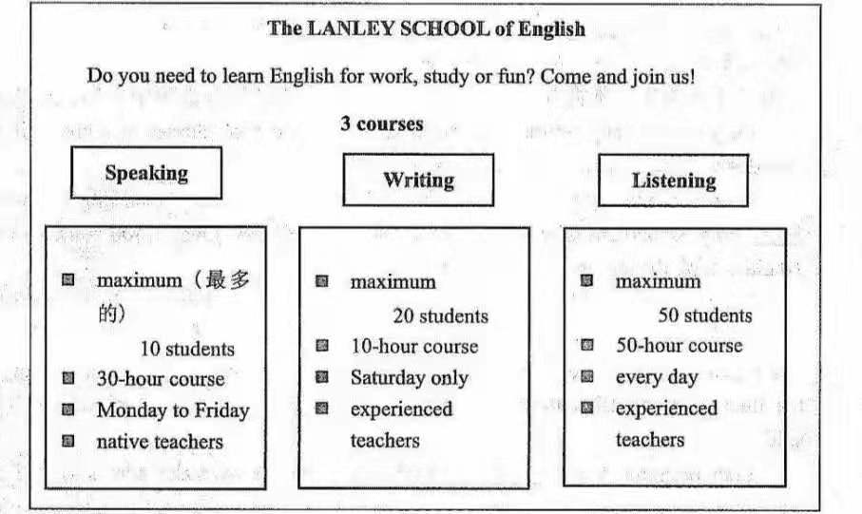**A**

51. What's the maximum students in the school?

A.30 B.60 C.80 D.90

52. On Sunday a student can__________.

A . take the writing course B . meet the native teachers

1. practice listening D.have a speaking class

**B**

Team games are important in school life. They help the children learn the importance of working together for a common goal. Team building activities help the students understand themselves and give them an opportunity to improve on their weakness.

Build a Story : This team game is about building a story from some pictures .

Each team is supposed to build a story according to the pictures given to each of its members . On understanding what each picture means , the team need to put the pictures in order . The team that is the first to build the story wins .

Team Craft(剪纸）:For this activity,the class is put into groups of three or four members. Each team is given some art materials like color pens, art paper and a knife.

Each team should come up with something creative and special. The one who finishes first or does the best in making craft will be the winner.

Team Sports: Outdoor activities and sports are some of the best team games for schools. Volleyball, soccer and basketball are some of the very interesting team games. Exercise mixed with fun is one of the most important interests of playing sports

Dog and Bone : This is played between two teams . The teams line up in front of each other. In team A, each member is given a different number. The same numbers are used for team B . An object is placed in an area between the two teams . The host(主持人）of the game calls out a number,the members with the same number from both teams rush to get the object. The member, who gets the "bone" first, make a point for his/her team.

53.What does the passage mainly talk about?

A. Team sports. B. Team games. C. Building a story. D. Team art.

54 . How can we build a story according to the second paragraph ?

A. To put the pictures in order. B. To say a sentence one by one.

C.To talk about the same picture D. To talk about different pictures.

55. In which game do you have to use color pens and a knife?

A.Dog and the bone. B . Playing volleyball .

C.Team craft. D.Build a story.

56. What is the "bone" in the game Dog and Bone?

A. The child who gets the object first.

B. The same number from both teams.

C.The game that the children play.

D. The object between the two teams.

**C**

Maybe you are an average student. You probably think you will never be a top student.This is not necessarily so, however, anyone can become a better student if he or she wants to.Here’s how:

**Plan your time carefully.** When you plan your week, you should make a list of things that you have to do.After making the list,you should make a schedule(时间表）of your time.First arrange your time for eating, sleeping, dressing, etc. Then decide a good, regular time for studying. Don't forget to leave enough time for fun. A weekly schedule may not solve all your problems,but it will force you to realize what is happening to your time.

**Find a good place to study.** Look around the house for a good study area. Keep this space which may be a desk or simply a corner of your room, free of everything but study materials.No games , radios or televisions ! When you sit down to study , focus on the subject .

**Make good use of your time in class.** Take advantage of class time to listen to everything the teacher says . Really listening in class means less work later . Taking notes will help you remember what the teacher says.

**Study regularly.**When you get home from school,go over your notes.Review the important points that your teacher mentioned in class. If you know what your teacher is going to discuss the next day,read that material.This will help you understand the next class.If you do these things regularly, the material will become more meaningful, and you will remember it longer.

**Develop a good attitude about tests.** The purpose of a test is to show what you have learned about a subject. They help you remember your new knowledge. The world won't end if you don't pass a test, so don't worry too much.

There are other methods that might help you with your studying. You will probably discover many others after you tried these.

57.A schedule will help you_____________.

A.find more time for fun B.solve all your problems

C. finish your work quickly D. know what is happening to your time

58. What should you do to help remember what the teacher says?

A.We should take notes. B.We should study regularly.

C. We should review the important points.

D. We should listen to everything the teacher says.

59. Which of the following is true?

A.Tests are the most important parts in your study.

B.You should review everything your teacher mentioned in class .

C.If you have a good place to study , you'll become a top student .

D.Planning work will make you clear about what to do and when to do it.

60. What's the main idea of this passage ?

A. It's about how to review your lessons.

B.It's about how to plan your time carefully.

C.It's about how to become a better student.

D.It's about how to make good use of your time in class.

**D**

Table manners are how to behave when you eat a meal. They include how to use knives,forks and spoons and how to eat and drink in a polite manner. To behave well abroad, you are know some table manners .

**Japan:** It is "perfectly"okay to slurp(饮食出声）when you eat noodles.Unlike making big slurping slightly is not rude . Japanese also say it tastes better if you slurp .

**Russia:** Your wrists(手腕） should be placed on the edge of the table while eating, fork in left hand, and knife in the right. Keep your elbows(射部） off the table. Leave some food on your plate to show that the host has given you enough to eat .

**France:** Never discuss money or religion over dinner. Compared with Russia, finishing everything on your plate in France is considered good manners .

**Mexico:** Whenever you catch the eye of someone who's eating, even a stranger, it's good manners to say "provecho",which means “enjoy” .In Mexico, dining is more than a meal. It's a social occasion(场合）.Lunches are seldom quick and suppers can last for hours . Where you sit is important in the country . Before you get seated , look for place cards , or wait until she host seats you . And you must also say " enjoy your meal " before you leave the table .

**Australia :** If you want to drink in Australia , it's usual to buy a round of drinks for everyone in your group . When it's your turn , say " It's my round " . When it's their round , they will buy it for you . Don't leave before you've bought a round .

61. When you eat noodles in Japan , it's good to_______.

A.make big noises B.slurp slightly

C. not to make any noise D.leave some food on your plate

62. You're supposed to eat all the food on your plate in______.

A.Japan B.France C . Mexico D . Australia

63.What does the underlined word"provecho"in the passage mean?

A.Thank you. B.Keep silent. C . Enjoy your meal . D.Have a good time.

64. Which of the following is TRUE?

A . It is good manners to put fork in right hand in Russia .

B.People in France like talking about money over dinner.

C . People like taking turns to treat each other in Australia

D.Strangers don't talk to each other in a restaurant in Mexico.

65. Why does the writer tell us the table manners in many countries

A. To invite us to these countries to enjoy foreign food.

B. To teach us how to handle knives, forks and spoons.

D.To make us able to express thanks to different hosts.

D. To help us behave in a polite manner in different countries.

V. 任务型阅读，阅读短文，并按要求完成36～40题。

It's common to carry things on bikes, trains and even planes. But do you know small drones（无人机） can help carry bags to your home？

For two years, Google has been working hard in their secret research lab. Their latest project is called Project Wing.

Project Wing is Google’s invention of a drone delivery(递送) service. It can deliver（递送）bags to buyers’ doors.

The first drone test was made on a farm in Warwick, Australia. It sent sweets and dog treats to a farmer. The drone flew to the farm, and released（释放）the bag with a rope. Delivery is here!

The best thing about drone delivery services is that delivery time will be greatly cut down. You’ll be able to order what you like on line in the morning. And by noontime, the delivery drone will land your bag.

Throughout history, there have been different kinds of inventions that have helped people move things around, said Astro Teller, lead scientist of Google Wing,to CNN. Teller thinks Google drones will be the next big step.

Interestingly, drones are not that young. The US has been using armed drones since 2002.But drones may also get another use. Film companies have asked to use them to shoot videos from the sky.

Yet Google’s delivery drones won’t be able to fly to buyers any time soon. However,Google has proved（证明）that drone delivery is possible. And with Amazon announcing（宣布）their drone delivery service last year, the pressure is to make safe and suitable drones to fly the skies for customers.

66题补全句子；67，68题简略回答；69题翻译划线句；70题给短文拟一个适当的标题。

66.Project Wing is___________________________________.

67.How long has the US been using armed drones?

68.What is the pressure of drone delivery service?

_________________________________________________

69.______________________________________________

70.______________________________________________

V. 词语运用。

When you visit a foreign country, it is important to know how to ask for help politely. For example, you may ask “Where are the restrooms?" or “Could you please tell me where the restrooms are?" These two requests are 71. s________ . Both are correct, but the first one 72. _________(sound) less polite. That is because it is a very 73. d______ question. It is not enough to just ask a question74. _______ (correct). We also need to learn how to be polite when we ask for help.

Good speakers change the way they speak in different 75._______

(situation).Their expressions might depend on 76.________they are speaking to or how well they know each other. It is all right to ask your classmates such a question “When is the school trip?" However, if you say to your teacher 77._____ same question, this might sound impolite. But if you say, “Excuse me, Mr. West. Do you know when the school trip is?", this will sound much more polite.

Usually polite questions are longer. They 78. _________ (including) expressions such as “Could you please...?" or “May I ask...?”or “Excuse me, ... “before asking for help. It might seem more difficult to speak politely than directly. It is important to learn how to use the 79. r____ language. Then you'll be more 80._________(success) in communicating with other people.

VI.连词成句

81.products, bean, protein, are rich in

________________________________________.

82.burning, keep, don't, candles, the

________________________________________.

83.trees, fifths, is covered with, two, the land,of

________________________________________.

84.I, dream, will, my, come true, believe

_______________________________________.

85.your, beautiful, are, how,kites

________________________________________!

VII.书面表达：

随着科技的发展，越来越多的人使用手机阅读，人们认为手机阅读更方便，对此请表达自己的看法，并说明理由。

参考词汇：read on mobile phone，convenient，download

字数要求：不少于80词

_______________________________________________________________________________________________________________________________________________________________________________________________________________________________________________________________________________________________________________________________________________________________________________________________________________________________________________________________________________________________________________________________________________________________________________________________________________________________________________________________________________________________