八暑提高第4讲讲案
教师：___________________ |  |  | 授课时间：___3小时_ | 备注
教  学  目  标 | 词汇 | Junk, junk food, coffee, health, result, percent, online, television, although, through, mind, body, such, such as, together, die, writer dentist, magazine, however, than, more than, almost, none less, less than, point
 | 句型
 | 语法 | 副词：1. 分类和用法，位置 2. 易错辨析
 | 口语/写作 | 口语：谈论业余活动  写作：如何保持健康
 | Step I  大纲词汇 | - Listen and repeat the new words.  - Explain the key words and phrases one by one.  1.health n. 健康；人的身体（或精神）状态  healthy adj. 健康的  2.percent n. (=per cent) 百分之......  percent 后不能加s， 谓语和percent后面的主语一致。  - although conj. 虽然；尽管；即使  although/though和but不能连用  4.mind n. 头脑；心智  make up one's mind to do 下定决心  mind v. 介意  mind (sb./sb.'s) doing sth.  介意（某人）做某事  5 die v. 死；枯竭；消失  dead adj. 死去的  - however adv.然而；不过  however,用逗号隔开。但but后不加逗号。  - Vocabulary practise  词汇练习--P36  - 自我巩固P13
 | Step II  语法 | 1.观看视频，明确副词的定义  2.副词的分类和用法：  （1）） 时间副词：表示时间的副词称为时间副词，是确定句子时态的重要标志。  时间副词放在句首或句尾  - ）地点副词：表示地点的副词称为地点副词，常用的地点副词有：here, in, out, home, off, back, up, away, near,outside, upstairs, anywhere等。一般放在句尾。  （3）频度副词：always, usually, often, sometimes, hardly ever, never,  位置：实前be/助/情后  对频度副词提问要用How often。  - 程度副词：very , quite, rather, too, so, much, enough  程度副词可以修饰形容词或副词的原级或比较级。  enough: 名前形后  - 方式副词：  方式副词大多数由“形容词+ly”构成。  注意：early, late, fast, hard形容词副词同形  形容词变副词口诀：  - 直接加ly.  - 辅音+y, y变ily  - le---ly  - 几个叛徒在里边：ugly ,lonely, lovely, friendly  3 易错词语辨析  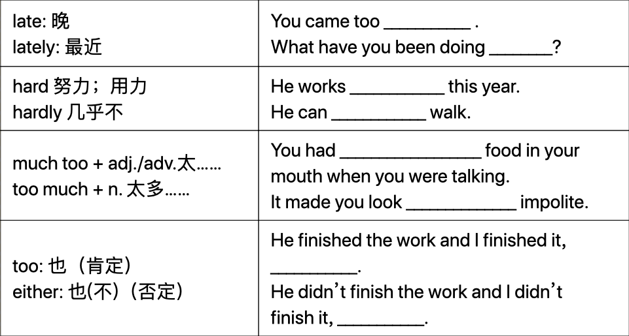  sometimes, some times, some time, sometime  - 语法整体练习（P40）
 | Step III  口语 | 1 说明口语练习话题： free time activities  - 说明话题涉及的关键词和短语  - Activities: exercise, play sports, go to the movies...  - Frequency: once a month, twce a week, every day...  - 学生操练
 | Step IV  写作 | - 说明写作步骤  - 带领学生审题：内容包括睡眠、饮食、运动三方面  - 列提纲，提示关键词和句型  - 完成作文本的关键句型  - 要求课下完成作文
 | Step V  Summary | - 大纲词汇  - 语法：副词  - 口语  - 写作
 | Step VI  冀教 | 1.带领学生朗读本课单词和短语  2. 讲解部分单词：  - immediately=at once=right away  - glad be glad to do sth  - hate to do/doing  - Either too, as well, also辨析  3 短语讲解  - play the violin 拉小提琴  - write down=take down =put down 写下；记下  4 文章句型  Pease ask your classmates about their interests.  I have one more question.  5 完成相关练习
Step VII
本周授课重点
 | Step VIII  本周作业 | 1. 爱学习app  专题课第4讲  口语练习第4讲  课前预习第5讲  自我巩固-线上提交  2. 微信教学：周？  3. 背诵： 单词

