八暑提高第6讲讲案
教师：___________________ |  |  | 授课时间：___3小时_ | 备注
教  学  目  标 | 词汇 | L1-5
 | 句型
 | 语法 | L1-5
 | 听力/写作 | L2和L4
授课内容及教学过程 | Step I  话题 | 复习课。
 | Step II  重点短语 | - 重点短语  1.go on vacation 去度假  每年夏天我都去青岛度假.  I ______________to Qingdao every summer.  2.have a good/great time 玩的开心=enjoy oneself =enjoy doing  =have fun doing  We ______________（玩得开心）in Xi’an last summer.  3. find out 查出来;发现  In the end, the police _______ (查出来;发现) that he was a thief.  look for 找的动作  find 找的结果  find out 通过调查、研究后“搞清楚、弄明白”  4.go on 继续 + to do/doing  After finishing your homework，I think you should ________  （继续）to read some books.  I told him to keep quiet in class，but he _________ （继续） talking with others movie ?  5.use/surf the Internet 上网 = go online  People can __________________to find out answers to many questions  6.at least 至少 —— at most 至多  We need ________ (至少) 20 students to clean the hall.  - be good at/ for/ with  Tom is _________ basketball .  Vegetables are__________ your health.  Jenny is__________ her friends, so they like her very much.  - 其他重点短语  keep a diary，be special to，explain sth.to sb，marry sb.；.get married to sb  be married，mind (sb./one’s) doing sth，keep/hold a record，break a record  set (up) a record，such as，of course ，go shopping ，in the past  too many ，because of ，up and down ，help with housework  on weekends ，be free ，stay up late ，not …at all ，more than
 | Step III  重点搭配 | 一、重点搭配  二、Explain the phrases one by one.  1.buy sb. sth.= buy sth. for sb.  My mother bought me a lovely dog.  2.decide to do sth决定去做某事  I decide_________ (go) on a field trip with my friends.  make a decision to do .make up one’s mind to do  - tell sb. not to do sth  My mom told me __________(not, play) in the street.  4.keep doing sth. 坚持/继续做……  If you keep_________(run), you will lose weight.  5.How about / What about……? …… 怎么样？  --________________（怎么样）listening to music?  -- That sounds like a good idea.  6.make sb. do sth.让某人做某事  They can always make people__________(笑).
 | Step IV  重点用法解析 | 一、Explain the phrases one by one.  1. anywhere & somewhere  anywhere “在任何地方”，常用于否定句和疑问句中。somewhere “在某处；到某处”，常用于肯定句中。  I can’t find it ________________.  I lost my key ______________near here.  2.quite a few & quite a little “很多；不少”  quite a few 修饰可数名词复数。  quite a little 修饰不可数名词。  He still stay here for _____________days.  There is ____________water in the bottle.  3.bored & boring  bored “厌烦的，感到无聊的”boring “无聊的，令人厌烦的”  I’m _________ with what he said.I find the story very__________.  4.try doing sth. & try to do sth.  try doing sth. 尝试做某事,不一定付出很多努力。  try to do sth. 尽力、设法去做某事，强调付出努力设法去完成。  我尝试给他打电话了，但是没有人接听。  I _____________him, but no one answered.  我正尽力把英语学好。  I’m ______________ English well.  5.forget to do & forget doing ——remember  forget to do sth. “忘记要做某事（事情还没做）”  forget doing sth. “忘记做过某事（事情已经做过了）”  不要忘记课后写作业。  Don’t ____________ your homework after school.  我忘记昨天写过作业了。  I ____________ the homework yesterday.  6.because & because of “因为”  because 引导从句，即接句子。  because of 可接名词、代词或短语。  He lost his job_____________ his age.  I didn't buy the shirt _________it was too expensive  7.sometimes &some times sometime & some time  有时我起床很晚。______________I get up very late.  下周某个时候我要去上海。I will go to shanghai _________next week.  我将会在这待一段时间。I'll stay here for____________.  他读这个故事几遍了。He has read the story_______________.  some time一段时间，表示“时间”时不可数，常与for连用，提问用how long。  sometime某个时候，可指过去或将来的某个时候。  some times几次 time作可数名词时, 指“次数”。  sometimes有时候 （=at times）, 提问用how often。  8.hardly & hard  hardly 副词,几乎不, 一般位于动词之前。  hard 副词, 努力地, 位于动词之后。  他几乎不工作。He ______________.  他工作努力。He ______________.  9.maybe & maybe  maybe “也许,可能” 为副词, 一般放句首。  may be “可能是，也许是”为“情态动词+be动词”结构（句中）。  也许你是对的。_________ you are right.  你也许是对的。You _________ right.  10.although & but  although 连词， “虽然，尽管”。but 连词，“但是”。  although 与but 不能同时使用。  _________ many students like to watch sports, games show are the most popular.  Many students like to watch sports,______ game shows are the most in popular.  11.but & however “然而，但是”  but 并列连词，可直接连接两个句子，表转折。  however 副词, 不能直接连接句子，必须用逗号与句子隔开。  She was ill. __________, she still went to work.  It is a sunny morning, ________ it is very cold  二、重点短语、句型演练  1.你到哪里去度假了？Where did you ____________ ?  2.去年暑假我去了纽约。 I _________New York City last summer.  3.你买了什么特别的东西吗？ Did you buy ________________ ?  4.我给妈妈买了一些有趣的东西。I_________________________ for my mother.  5.大家玩得开心吗？Did everyone ________________?  6. 你周末通常做什么？What do you usually do________________？  7. 他们经常帮助干家务活。They often__________________________.  8. 你多久看一次电影？ ___________do you go to the movies?  9. 我可能一个月看一次电影 I go to the movies_____________________.  10. 他几乎不看电视。 He _____________ watches TV.  11. Sam的头发比Tom的长。Sam has_____________than Tom.  12. Molly不如Larry擅长网球。Molly isn’t ________________as Larry
 | Step V  重点语法 | 一、复合不定代词  1. 基本用法及构成  (1) some-类不定代词多用于肯定句中，也可用于表示邀请、请求或建议的疑问句中，表示问话者希望得到肯定答复。  (2) any-类不定代词多用于否定句和疑问句中，也可用于肯定句中，表示“任何人、事”。  2.复合不定代词做主语，谓语动词要用第三人称单数形式。  3.复合不定代词若有定语修饰，该定语要置于其后  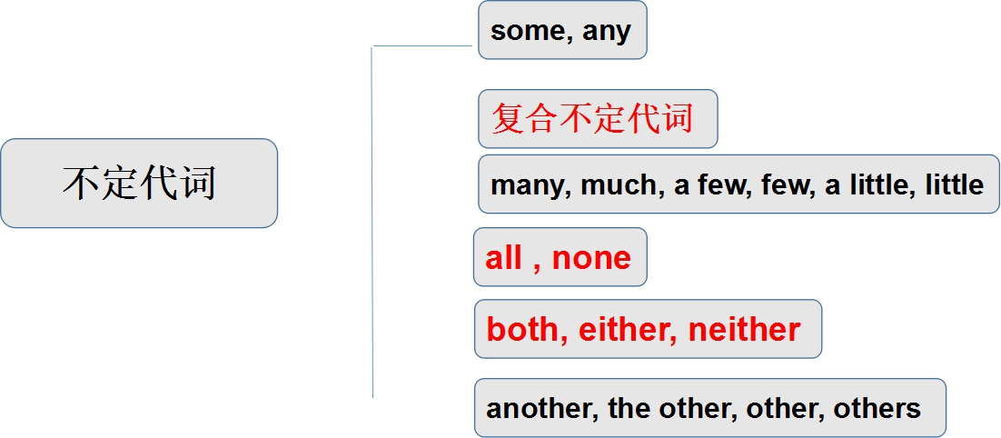  - 练习  1.我有重要的事情告诉你。  __________________________________  2.你想要点喝的么？  __________________________________  3.任何人都可以使用这个游泳池。  __________________________________  二、both/neither/either/all/none  1.both两者都(复数）；neither两者都不（单数）；either，两者中任何一个（单数）  all三者及以上都（复数）；none三者及以上都不（可单可复）；any 三者及以上任何一个、  2.就近原则:  neither...nor…；either...or...；not only…but also…  - 练习、  1. --Have you seen the two movies?  --Yes, I think ______of them are interesting.  2. ________Lily nor Lucy is in the classroom.  3. Bob and I are ______interested in English.  4. --Do you want pop or juice?  --_______. I really don't mind.  both, neither..nor, either...or  1. I like ________pop ______coffee. I like water.  2. When Lily is unhappy, she _____ goes shopping ___ listens to the music.  3. I like _______of the two boys, because they are hard-working.  4. Neither I nor he ____(be) a doctor. Both of us are students.  5. Either he or you ____ (be) going to see the film. There is only one ticket.  6. Not only you but also I _____ a teacher.  7. We have three computers at home, but ______ works well.  三、another/the other/others/the others  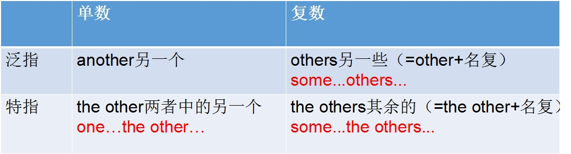  e.g. I have two albums. One is red, __________ is green.  e.g. Some students are in the classroom, _________________  are on the playground.  e.g. There are fifty students in my class. Twenty of them are  boys, _________________________ are girls.  练习  I don’t like this shirt. Could you show me _________ one?  I bought two bicycles, one is blue, ________ is red.  Some people went there by car, _________________went there on foot.  Ten students have passed the test, _________________haven't.  四．副词  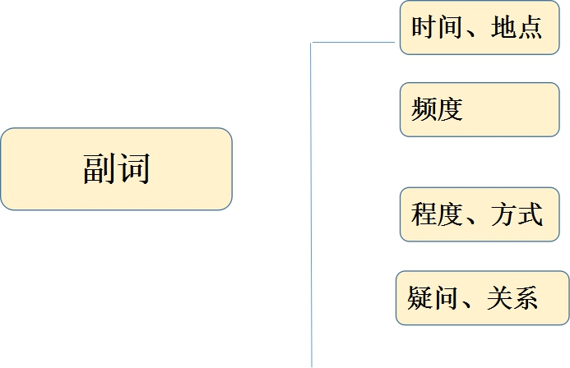  频度副词  1.定义：表示次数、频率的副词。  2.位置：实前在be动/情动/助动后，强调——句首/句末。  3.always,usually,often等常与一般现在时连用。  4.always与进行时连用时，表示赞叹、厌烦等情绪  1.他有时在晚上看电视。  _______________________________  2.这里经常下雨。  _______________________________  3.他总是想着别人。  _______________________________
 | Step VI  作文 | 一 写作思路  1. 审题（时态、人称、文体、要点）2. 列提纲（三段式：总分总）  3. 扩写：丰富词汇、句式（宾从，感叹句）  4. 检查（句子开头字母大写；名词单复数；不同时态谓 语动词的形式要正确；拼写）  5.例子  （1）Mary正在向我们介绍她上一次度假的情况。  请你参考作文本中的有用句式，介绍你最近一次的度假情况。  要点包括：  1. Where did you go on vacation?  2. What did you do ?  3. How did you feel about the vacation?  要求:不少于60词  Last week I went to Qingdao on vacation with my family. we had such a great time there.  It took us three hours to get to Qingdao by plane. We were attracted by its beauty as soon as we arrived there. There are many places of interest in Qingdao, such as Laoshan Mountain. We took quite a few photos there. As Qingdao is a seaside city, we ate various kinds of seafood and they all tasted delicious, especially the lobsters. We also did some shopping and I bought something interesting for my friends.  That was a really wonderful vacation. I hope I could go there again in the future.  - 每个人都希望保持健康。良好的生活习惯对每个人都非常重要。请从睡眠、饮食、运动等方面进行阐述，简要介绍一下如何才能保持健康。参考作文中的有用句式，写一篇不少于60词的文章  All of us want to be healthy. So, it is important for us to keep some good living habits.  First, usually we need about eight hours' sleep every night. Without enough sleep, we won't feel good during the day. So, we should never stay up late. Second, a healthy eating habit is also important. As the saying goes, “An apple a day keeps the doctor away.” We should eat more vegetables and fruit because they are good for us. At the same time, we shouldn't eat too much junk food, such as hamburgers and chips. Finally, everyone needs to do some exercise to keep in good health.  In a word, good health depends on good living habits.
 | Step VII  冀教（Lesson5）Meet Ms. Liu | - 课文呈现  THINK ABOUT IT  ·What is your teacher's name? What do you know about him/her?  ·How do you feel when you talk in front of your class?  It's English class. Li Ming is standing at the front. He is ready to give  his report to the class.  I talked to someone very special —our English teacher，Ms. Liu I feel lucky to have her as my English teacher. She learned English at a university in London，England. She started teaching seven years ago. She is knowledgeable，and her lessons are interesting. She encourages us to ask questions and discuss the answers with each other. She is kind and patient. After class，she is our good friend.  Ms.Liu has many interests. She likes to swim for exercise. She plays the piano，and she is a very good singer，too. What does Ms.Liu hate? Walking to school in January! It's cold in January.  That's Ms.Liu. Thank you!  Learning Tip  My name is Yang Hui. I'm married. My husband is “Mr.” Liu. You can call  me“Ms.”Yang or “Mrs.” Liu. My daughter is single，so you can call her “Miss” or “Ms.” Liu.  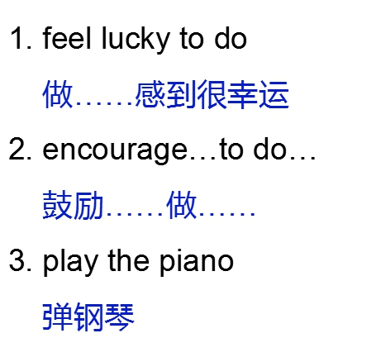  二、呈现单词和短语  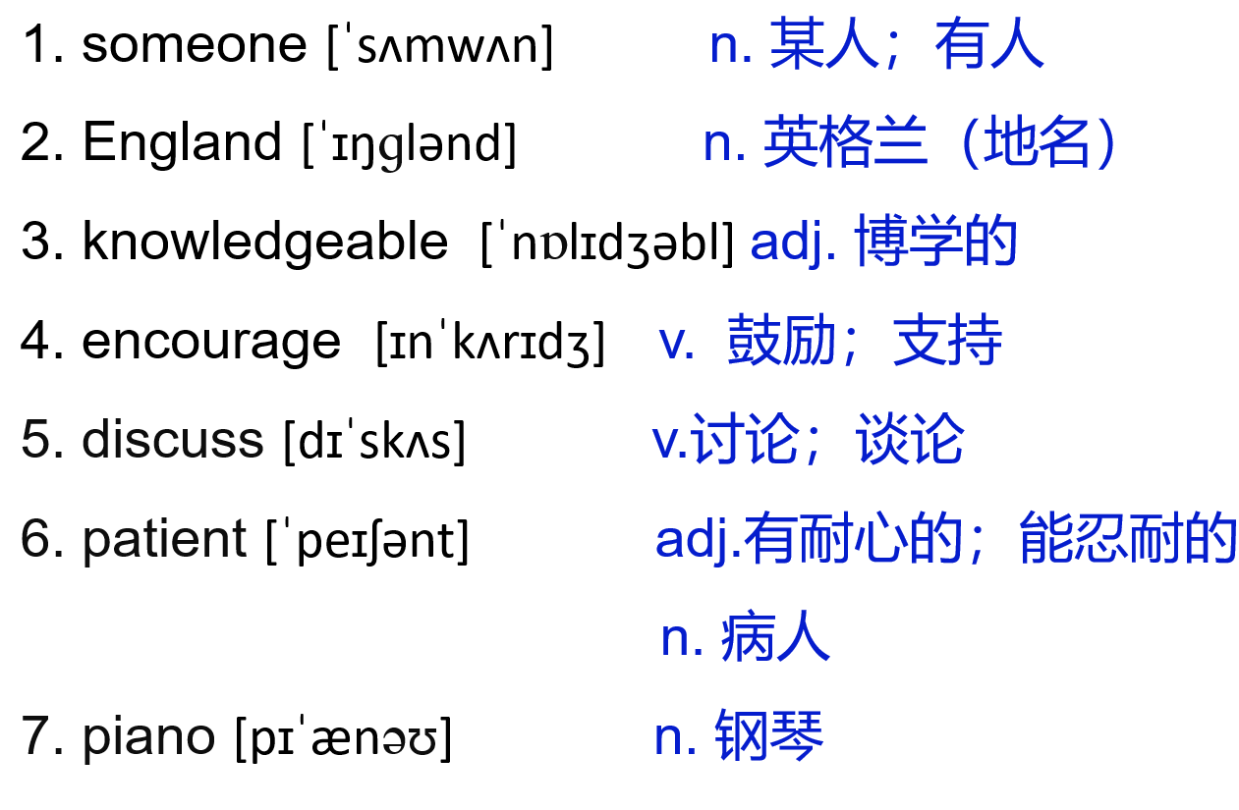  - 课文讲解  1、He is ready to give his report to the class.他已经准备好给全班做报告了。  考向：be ready to do sth. 准备好做某事  be/get ready for + n. 为……做准备  eg：He’s always ready to help others.  他总是乐意帮助别人。  Be ready for the lesson in five minutes.  准备好五分钟后上课。  —Why does everyone like that boy?  —Because he _______________________________________.  (总是乐于助人) (ready）  2.I talked to someone very special —our English teacher，Ms. Liu  我同一个非常特别的人——我们的英语老师刘老师谈过。  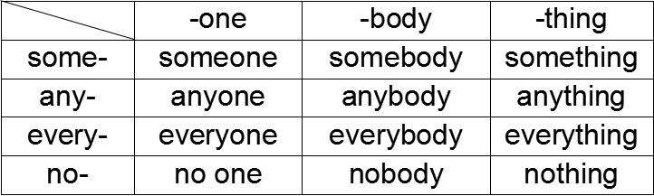  复合不定代词 作主语时，谓语动词要用第三人称单数；  形容词、不定式等修饰复合不定代词时，要放在复合不定代词的后面。  - I feel lucky to have her as my English teacher.  我感到很幸运有她作为我的英语老师。  feel lucky to do...意为“做……感到很幸运”  I feel lucky to be a volunteer.  作为一名志愿者我感到很幸运。  lucky拓展： 名词: luck 副词: luckily 反义词：unlucky  eg: Our teacher said “Good luck” to us before the exam.  老师在考试之前祝我们好运。  Luckily, Lucy caught the train at the last moment.  幸好，露西在最后时刻赶上了火车。  5.She encourages us to ask questions and discuss the answers with each other.她鼓励我们互相提问，讨论答案。  encourage sb.to do sth.意为“鼓励某人做某事”。  eg：His parents encourage him to speak in public.  他的父母鼓励他在公众场合讲话。  名词：encouragement 鼓励  discuss sth. with sb.意为“与某人讨论某事”。  eg：He discussed the problem with his parents.  他和他父母讨论了这个问题。  名词：discussion  have a discussion about sth. “对某事进行讨论”。  eg： Do you want to have a discussion about the culture?  你想讨论一下文化吗？  6.I'm married  marry sb. 嫁给某人；与某人结婚。  eg：John married Mary last week.  上星期约翰和玛丽结婚了。  be/get married to sb. 表示与某人结婚。  eg： Jane was/got married to a doctor last month.  上个月简和一位医生结婚了。  marry sb. to sb. 表示父母把女儿嫁给  某人或为儿子娶媳妇。  eg： She married her daughter to a businessman.  她把女儿嫁给了一位商人。  五．练习
 | Step VIII  本周授课重点 | L1-5重点短语、搭配、词义辨析、语法、作文  冀教Lesson5
 | Step IX  本周作业 | 1.线上作业  （1）专题课，观看并整理笔记  （2）完成口语跟读作业  （3）自我巩固——线上提交  （4）课前预习（课前）  2.线下作业  （1）听写大纲词汇和文章词汇  （2）微信教学

