七暑课优第8讲讲案
教师：___________________ |  |  | 授课时间：_________________ | 备注
教  学  目  标 | 词汇 | Group 1 教室里的物品：do， have ，has， play， basketball, volleyball, soccer，soccer ball, tennis， ping-pong ball， bat  Group 2 形容词表达观点：interesting, boring, fun, difficult, relaxing  Group 3 邀请参加活动：let， us， go
 | 句型 | - 询问教室里面的东西  A : Do you have a_____?  B: Yes, I do.  - 表达观点  A : What do you think of playing basketball ?  B : It's _________.  （3）邀请参加活动  Let us do ……
 | 语法 | 一般现在时：  结构： Do / Does +主语+ have +其它 ？  肯定回答：Yes, 主语（代词）+ do / does .  否定回答： No, 主语 (代词) + do / does not .  在口语中, do not 经常缩略为 don't / does not 经常缩略为 doesn't.  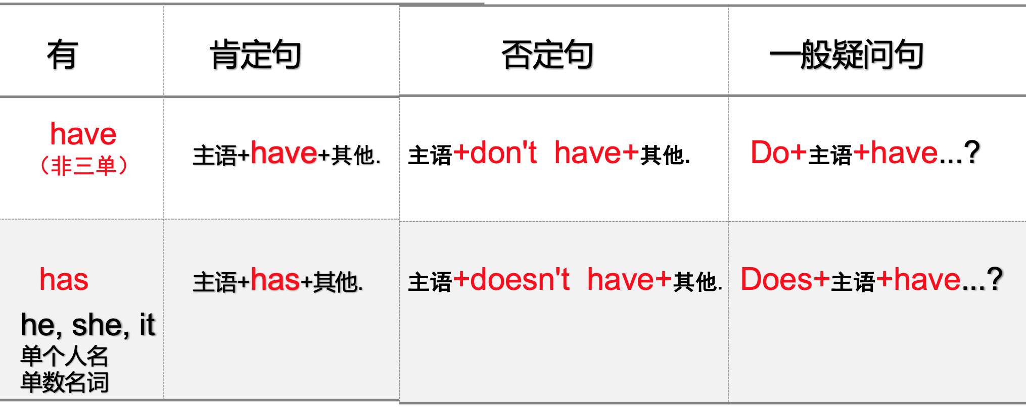
 | 听力 | （1）听句子选对话 （2）听短文，选择最佳答案
授课内容及教学过程 | Step I  话题 | Warming-up: 单词和图片配对  方式：给学生10秒钟，熟悉图片。老师指图片，学生抢答英文单词。
 | Step II  大纲词汇 | 一、导入：do you like sports? which sport do you like best? Now, here are something for sports.  Group 1： 教室里的物品  - 听音并跟读。  - 每个学生读一个单词，老师纠音。  - 串联单词
 | Step III  文章 | Group 1 师生练习  老师：Do you have a basketball? 学生：Yes, I do.  Now i'll choose two students to practice this sentence with the words  生生互练习，练习到每个单词  Group 2 师生练习  老师：What do you think of playing basketball? 学生：I think it is（用所给单词）  生生互练  老师总结：paly+球类  做练习题  Group 3师生练习  老师：when your friends invite you to play basketeball, what will you say?  学生：Great, let us go.  老师总结：Let us=let’s？  老师：请观察一下，let 后面的人称代词是宾格还是主格？学生：宾格  老师：yes，动词后面接……？ 学生：宾语。  老师：very good，let 后面动词要用……？ 学生：原形。  句型操练：  老师：Now，We are going to do some sports，here are something for sports. You should ask your partner if she or he has。  学生AB角色扮演，朗读。更换单词（Dialogue-1和2）  Dialogue-3:  老师？let at this dialogue，2 of you will say the key grammar。And，pk。 我们看看在有限的时间内，谁说的最多。每人十秒钟。
 | Step V  语法 | Grammar ： 一般疑问句  I、看小视频。  II、判断正误：  老师：here are some sentences，let‘s see if it is right or wrong。  III、学生总结：have，has的用法（老师强调一下什么是单三）  have/has习题  同样的方法进行否定句、一般疑问句的发现和总结+习题  最后：表格总结-口诀-综合练习
 | Step VI  Listening | Next, let’s listen to the tape and practice listening.  First. Look at the questions.  听力题型（1听句子和对话，选择与所听内容意思相符的一项。）（2听短文，选择最佳答案）  We’d better master the skills first. Then do the exercises.  第一个题操作方式如下：  - 迅速浏览选项，猜语境。  - 听听力，做题  - 学生PK说答案  老师：choose one student to read the question.  Then listen to it. Check the answers at last.  听力原文：重点单词解读意思  第二题操作方式如下：  - 读题+圈出关键词  - 听听力，做题  - 校对答案  老师：choose one student to read the question and circle the key words. Then listen to it. Choose two ss to say the answers at last.  听力原文  老师：Let's read the text of listening and review how to do the listening exercises
 | Step VII  总结 | Summary  老师：that’s all for the new lesson. Do you still remember them.  Look at Chinese， can you say them in English?  本课重点  1.询问教室物品的句型：Do you have a……？yes，I do/ no，I don’t  2.表达观点：what do you think of doing sth？ It is……  3.邀请参加活动： let us do……  4.have/has的用法  