八暑提高第2讲讲案
教师：___________________ |  |  | 授课时间：___3小时_ | 备注
教  学  目  标 | 词汇 | activity decide try feel like wonder difference wait because of below enough wet hungry dislike bird bicycle building trader top umbrella as hill duck paragliding
 | 句型
 | 语法 | - some, any, 用法  - 复合不定代词  - many, much, a few, few,a little,little  - all , none  - both, either, neither  - another, the other, other, others  - each, every
 | 口语/写作 | 练习“节日和假期” 话题相关的口语和写作
 | Step I  大纲词汇 | - Listen and repeat the new words.  - Explain the key words and phrases one by one.  1.activity n.(国际）活动  What __________________do you find enjoyable?  active adj. 积极的；活跃的  e.g. Tom is very____________ in student____________.  actively adv.  act v.  actor/actress n.  2.decide v.决定；选定  Think about it before you __________________  decide（not）to do决定（不）做某事  decide that 决定  e.g. I decide （not）to go shopping today.  e.g. I decide that_______________________ today.  decision n.决定  make a decision to do 做决定  make up one’s mind to do  3.try v/n. 尝试；努力；设法  try to do sth.努力/试图做某事 try one’s best to do尽力做某事  try doing sth.尝试做某事  e.g. I tried_____________(get) a good grade,but failed.  e.g. Let's try___________(knock) at the back door.  try n.尝试；have a try  e.g. Do you want to try it?(用名词形式改写句子）  e.g. Do you want to have a try?  Try again ! Do you want to have another try?  5.feel like 给...的感觉；感受到  feel like 后接名词，代词或者从句  e.g. We met three years ago,but it____________it was yesterday.  This kind of cloth feels like silk.  We will take it if you feel like it.  feel like 还可以表示“想要”  feel like doing sth  e.g. I don't feel like _____________(eat) anything.  6.wonder v.想知道；琢磨  wonder后常接wh-或者how从句  e.g. I wonder____________the boy is.  e.g. I wonder _____________she comes here.  wonder n.奇迹，奇观  e.g.The Great Wall is one of the 8 great _____________in the world.  7.difference n.差异；差别  The twins look the same, but they also have some ___________.  different adj.不同的；有差异的  be different from 和...不同 be the same as 与...相同  e.g. The twins are______________each other.  make a difference 有影响，起（重要）作用  tell the difference between A and B 分辨a和b的区别  My mum makes differences to my life.(翻译）  我的妈妈在我的生活中产生了影响  8.wait v.等待；等候  Someone is __________________you in the next room.  wait 是不及物动词  wait for 等待人/物  wait at+地点 在...地方等  can't wait to do ...迫不及待做某事  I will wait _____you _____the school gate.  A.at;for B.for ;at  I can't wait to see the birthday gift from my mum.(翻译）  我迫不及待的想看妈妈给我的生日礼物。  9.because of 因为  because of 为介词短语，后接名词性成分表示原因  because后接原因状语从句表示原因.  I didn't go home yesterday __________it rained.  I didn't go home yesterday __________________the rain.  We didn't go to the park because the weather was too bad.(转换句子）  We didn't go to the park because of the bad weather  10.below prep＆adv.在...下面；到...下面  From the top of the mountain I could see the village_________.  Water becomes ice when the temperature is _________0℃.  below的反义词为above意为“超过；在...之上”  It was five degrees above zero last night.  11.enough ad/adv.足够的（地）；充分的（地）  enough做形容词修饰名词，要放在名词前  enough作副词修饰形容词或副词，要放在形容词或者副词后  1.You are ______now,Bill.you should wash your clothes by yourself.  A.young enough B.enough old  C.old enough D.enough young  2.Is there_________milk for me?  A.many B.a few  C.enough D.few  形容词+enough+（for sb.）to do 对于某人来说足够...能...  too+形容词+（for sb.）to do 对于某人来说太....不能...  12.dislike v.＆n.不喜欢（的事物）；厌恶（的事物）  I ______________playing computer games  Here are my likes and dislikes. n.  like v.喜欢 dislike doing v.不喜欢  like prep.像 unlike prep.不像  He looks _________his mother.  A.unlike B.dislike  He dislike ________(play) the piano.  I ______________playing computer games  Here are my likes and dislikes. n.  like v.喜欢 dislike doing v.不喜欢  like prep.像 unlike prep.不像  He looks _________his mother.  A.unlike B.dislike  He dislike ________(play) the piano.  - Vocabulary practise  词汇练习--基础练习  I.首字母填空(P14)  1.Don’t worry. We’re old e________ to look after ourselves.  2.The food tasted great because I was so h__________.  3.People enjoy many different a_____________ in their free time.  4.I w_________ what life was like in the past.  5.Eric’s grandfather is a t__________ who sells goods in the city.  6.Please be quiet.B_______the baby is sleeping.  词汇练习---重点考点突破  1.Tom is ____boy.He takes part in lots of _____.  A. an active ;activities ; B.a active ;activity  C.an active;activities ; B.a active ;activities  2.He decided ______ a desk for his sister.  A.make B.to make C.making D.made  3.He tried his best ________his homework on time.  A.to finish B.finish C.finishing D.finishes  4.He doesn't feel like _____now .He wants to watch TV.  A.sleep B.to sleep C.sleeping D.sleeps
 | Step II  语法 | 一、说出下文中标出颜色单词的意思  1.He asked for tea, so I gave him some.  2. None of them believed his story.  3.Someone is waiting for you.  4. I have two pens. One is red, and the other is blue.  5. I don't like this pen ,please show me another.  引出不定代词定义：不指明代替任何名词或者形容词的代词叫做不定代词  二、some＆any  A：Are there________ apples in the fridge?  B:Yes, there are_______.  C.No, there arent _________.  e.g.有些钱被偷了。  ______of the money was stolen.  e.g.我一点面包也没有了。  I don't have______bread left.  If there is _______trouble,let me know.  some和any可以代替或修饰可数名词复数或不可数名词。  some一般用于肯定句，  any一般用于否定句、疑问句和条件从句。  当问句表示，一种邀请或请求,或期待肯定回答时可以用some。  e.g.你想再喝点儿咖啡吗？（you,like,more,coffee)  Would you like some more coffee?  some接可数名词单数表示“某个”。  e.g.外边有个女孩儿在找你。（girl，look for，you）  Some girl is looking for you outside .  any用在肯定句当中表示“任何一个”  Any student can go there.  三、复合不定代词  I.定义：由some，any， no， every加上-thing，-one，-body构成的不定代词叫做复合不定代词。-one和-body构成的复合不能代词可以互换。  1.There is someone/somebody in the room.  2.Is there anyone/anybody room?  3. There isn’t anyone/anybody in the room.  4. You don’t have a drink. Can I get you something?  5. Anything is possible.  II.用法：  1.some类的不定代词用于肯定句中；也可以用于表示希望得到肯定回答的疑问句中。  2.any类的不定代词用于疑问、否定或条件句中。若用在肯定句中表示“任何人/物”。  3.复合不定代词 作主语时，谓语动词要用第三人称单数  （1）Well,everyone_________( want) him to win.  （2）. Nobody________(know) what the future will be like.  （3） There__________(be) something wrong with my watch.  4.不定代词 若有定语修饰，该定语要置于其后。  e.g.There is something interesting on the front page.  e.g.Ask somebody else to help you.  （1）这台电脑没问题。  There isn't______________________with the computer.  （2）你有什么要说的吗？  Do you have____________________________?  III.观看视频讲解  四、 many/much/a few/few/a little/little  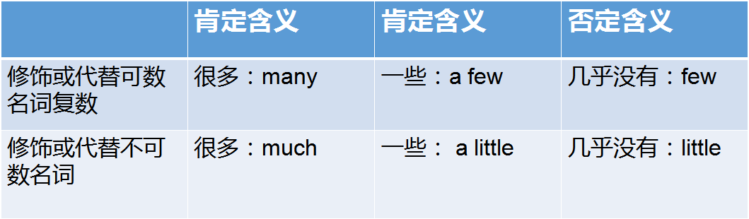  I.Practise选词填空  There are too______________ mistakes in the essay.  I haven't got __________ money.  There are __________ minutes left ,aren't there? Don't worry！  There are __________ minutes left, aren't there? Hurry up!  There are __________ time left ,isn't there? Don't worry！  There are __________ time left, isn't there? Hurry up!  II.注意：too many,too much 和much too的辨析  Practise选词填空  There is _________bread on the table.Let's have some.  There are __________ apples on the table .Let's have some.  I feel _________tired .  五、all＆none  I.all表示三者及三者以上都，none为其完全否定形式  e.g.我们都喜欢吃苹果。  All of us like to eat apples.  e.g.钱没丢（没有钱丢了)。  None of the money was lost.  II.none可以用来回答How many/much引导的特殊疑问句  -How many students are there in the classroom?  -None.  六、both/neither/either  I.both,neither,either 都表示两者之间  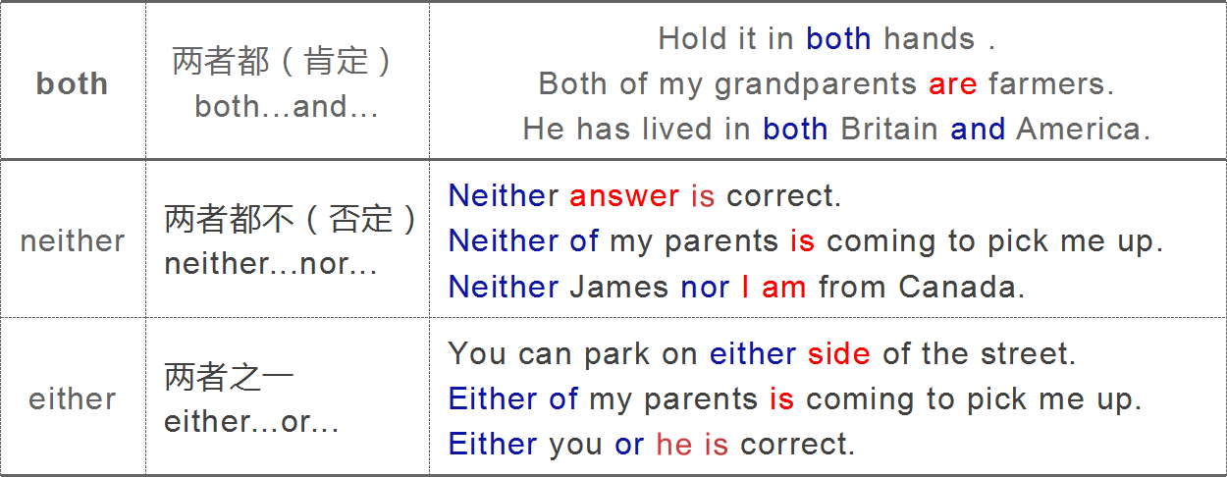  II.neither...nor, either...or...就近一致原则  III.观看视频讲解  IV.both,neither..nor,either...or练习  1.I like ____of my parents.They like me ,too.  2.I like _______football _____basketball .I like pingpong.  3.When the girl is happy, she _____ sings ____ dances.  4.I like ______of the two boys .Because they treat me badly.  5.Neither I nor he _____(be)a teacher. We both are students.  6.Either he or you______(be) going to see the film .There is only one ticket.  7.Both you and I _____teachers .  8.Not only you but also I am a teacher.  not only...but also :不仅...而且 就近原则  七、another/the other/others/the others  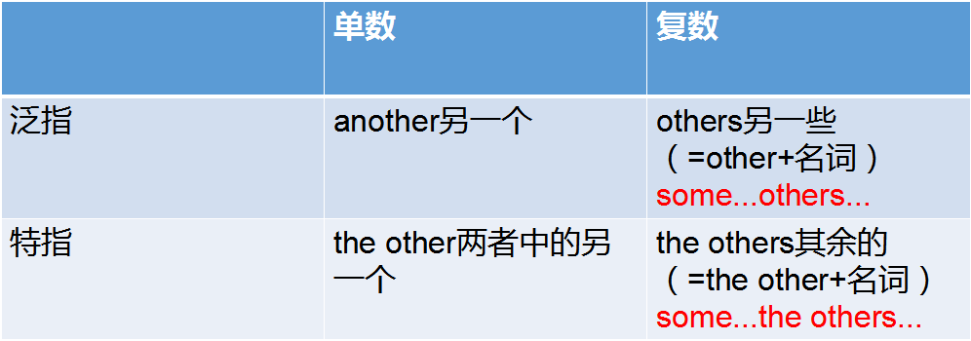  I.举例说明  e.g.I have two apples. One is red,the other is green.  e.g.Some students are in the classroom, others( other students) are on the playground.  II.视频讲解 other家族  III.Practise练习  我不喜欢这个房间，我们换一个吧。  I don’t like this room. let's ask for__________.  我买了两本书，一本是字典 ,另一本是语法书。  I bought two books： one is dictionary, ______________ is grammar book.一些人是坐车来的，另外还有一些人徒步而来。  Some people came by car ,______________________ came on foot.  有八个学生通过了考试，其余学生则没有通过。  Eight students have passed the test, ______________________haven't  e.g.Can you give me another cup of water? I am still thirsty.  八、every& each  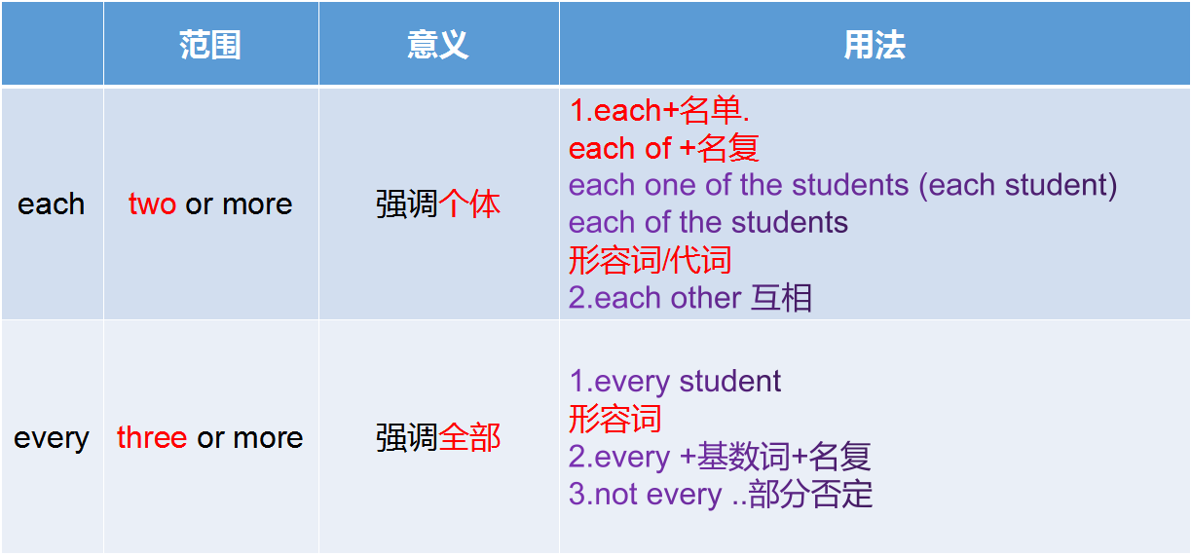  I.Practise练习  ________ of the answers is worth 20 points.  ____side of the road is planted with flowers.  The buses go _______ 10 minutes.  Not______girl can go to school in India.  They are good friends .They love _____other  九、语法整体练习（P18）  I.something,somebody;anything;anybody;nothing;nobody;everything,everybody  1.There is_____________________ wrong with his computer.  2.—Do you know ____________ about the US?  — no I know_____________ about it.  3.____________is in the room.So you can't hear any voice.  4.____________ except Li Ping went to the park. He was ill  II.another,the other,others,the others,other  1. He has a basket in one hand, and a book in_____________.  2.I don't like this shirt, please show me___________.  3. Some of the boys were out running, while________ were watching TV.  4. The clock has three hands. One is short,_____________ two are long.  III.little,few,a little,a few,many,much  1.-Would you like some wine?  - Yes,just ________________.  2. The question is so difficult that very__________ students in our class can answer it.  3 . He made so _______mistakes in the test that the teacher was very angry with him .  4. Middle school students always have too ______homework to do.  IV.both,neither,either,all  1.--Did you read the two books?  --Yes,I think ___________of them are interesting.  2.___________Lily nor Lucy is on the team.  3.My parents and I are _________interested in Chinese food.  4.--Do you want tea or coffee？  --____________.I really don't mind.  十、语法整体练习（P19）  1.—Do Bob and Henry like playing computer games?  — Yes, ____of them does.  A. none B.all C.every D. each  2.My sister has two skirts. One is yellow,__________ is black.  A.other B.another C.others D. the other  3._______ of these two boys are outgoing.  A.All B.Either C.Both D.Few  4.The problem is so hard that almost ___________ can work it out.  A.nobody B. somebody C.everybody D. anybody  5. Please give me ___________ apples.  A. more two B. another two C. much D. more much  6. Would you like____to eat?  A. anything else B. else nothing C. else something D. something else  7 . - How many people are going to visit the museum tomorrow ?  A.Any B.None C. No one D.Not one  8.-I'm afraid I can't finish my paper on time.  - Don't worry . You still have _ days to work on it .  A.a few B. a little C.few D . little  9 . - We have red and yellow T-shirts . Which color do you like ?  - I am afraid____.I think blue will be OK.  A.both B. either C.neither D. none  10. Neither the students nor the teacher___the answer to the question.  A.knows B.know C. don't know D. doesn't know
 | Step III  口语 | Pretend that you are talking with a friend about your vacation. Find a partner and complete the following conversation. The phrases in the box can help you.  A:Hi. Long time no see.  went to the mountains  went to the beach  visited the musuems  went to the summer camp  went to the New York City  B:Hi.Yes.I was on vacation last month  A:Wow!Where did you go?  B:I...  A:Did you go with anyone ?  B:Yes,I went with my family.  A:Did you buy...?  nothing  anything special  something interesting  ...  B: Yes/No,I...  A: How was the food?  B: Everything tastes good.What about you?  What did you do last month?  A: I just stayed at home most of the time  to read and relax.
 | Step IV  写作 | - 写作主题及要求：  Mary正在向我们介绍她上一次度假的情况。  请你参考作文本中的有用句式，介绍你最近一次的度假情况。  要点包括：  1. Where did you go on vacation?And how did you go there?  2.Who did you go with?  2.What did you do ?  3.How did you feel about the vacation?  要求:不少于60词。  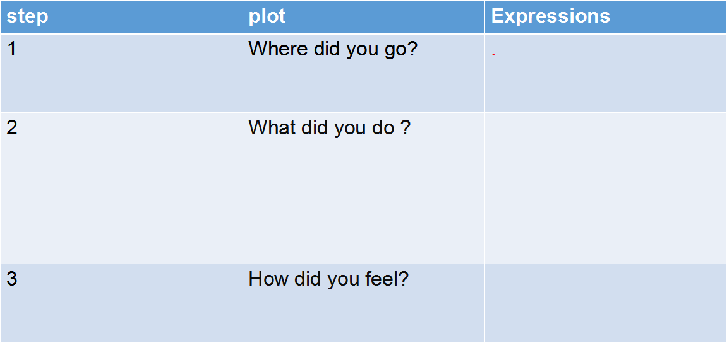  II.Brain storm  Beijing,Sydney, museum mountain..  visited places of interest,ate delicious local food,bought something interesting, met someone special,took photos.  Unforgettable experience;  go there again...  III.参考句式  1.我和家人上个月去北京度假了。  I went to Beijing_______________________________last month.  2.我们玩得非常开心。  We_________________very much./We___________________.  3.我们乘飞机去的那里。  We went there________________.  4.北京是一个非常棒的城市。  Beijing is a ____________________city.  5.我们拍了很多照片。  We took_____________________photos there.  6.北京有各种各样的食物，尝起来都非常美味。  There are________________ _____food in Beijing,and they all tasted delicious.  7.我还给我的朋友们买了一些有意思的东西。  I also bought_______________________for my friends.  8.这真是一次难忘的假期。  This was really an ____________________experience!  IV.写作练习  Last week I went to Qingdao on vacation with my family. we had such a great time there.  It took us three hours to get to Qingdao by plane. We were attracted by its beauty as soon as we arrive there. There are many places of interest in Qingdao, such as Laoshan Mountain. We took quite a few photos there. As Qingdao is seaside city, we ate various kinds of seafood and they all tasted delicious, especially the lobsters. we also did some shopping and I bought something interesting for my friends.  That was a really wonderful vacation. I hope I could go there again in the future.
 | Step V  Summary | - 大纲词汇  2.不定代词（some＆any；复合不定代词； many/much/a few/few/a little/little；all＆none；both/neither/either；another/the other/others/the others）  3.every& each
Step VI
冀教
Step VII
本周授课重点
 | Step VIII  本周作业 | 1. 爱学习app  专题课第2讲  口语练习第2讲  课前预习第3讲  自我巩固-线上提交  2. 微信教学：周？  3. 背诵： 单词

