八暑提高第1讲讲案
教师：___________________ |  |  | 授课时间：___3小时_ | 备注
教  学  目  标 | 词汇 | housework,internet,program,swing,hardly,hardly ever,once,twice,full,maybe,least,at least; survey, debate, record, select, choice, otherwise,add,organise ( organize )
 | 句型 | 1.宾语从句He explained that the English lesson was called  “How Often -?”  2. 定语从句：The work the students had to do was called a survey.  3.宾语从句：Chen Lee asked Mr. Barrett to explain what he needed to do.  4. 宾语从句：They may say they do something more often than not.'  5. 宾语从句：The school wants to find out how active our pupils are.  6.宾语从句：We want to be sure ( that ) they are not couch potatoes on weekends.
 | 语法 | - 使用频率来回答日常生活活动
 | 听力 | 初中英语听力必备话题--：谈论日常生活：爱好，饮食，活动
授课内容及教学过程 | Step I  话题 | 以What do you do in your free time? 为题导入，匹配动词短语与图片。
 | Step II  大纲词汇 | - Listen and repeat the new words.  - Explain the word “full”and then do a survey to explain the other words.  - full  I am ______ now, so I don't want to eat any more.  My stomach is _______ of food.  My brain is _______ of words.  be full of = be filled with ... 满是……  2.Do a survey  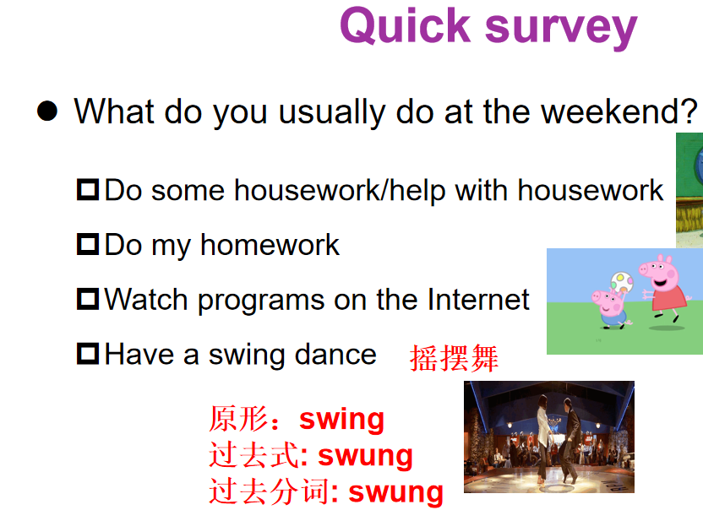  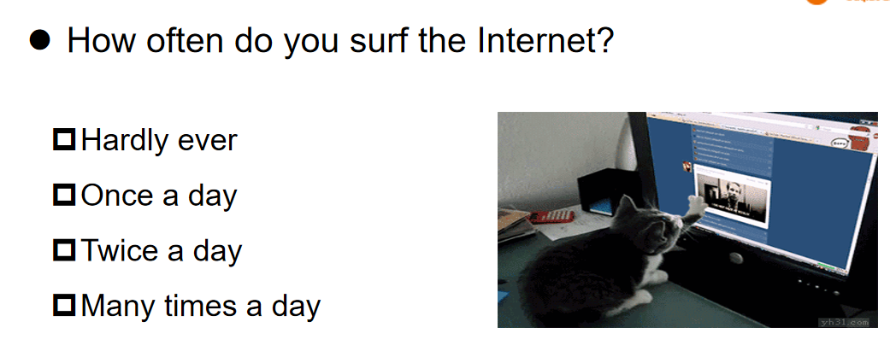  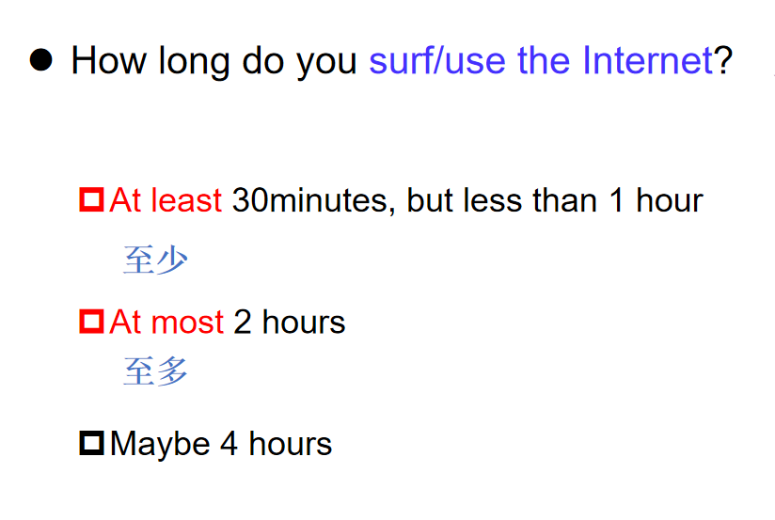  精讲词汇  - .hardly  I buy what I need on the Internet (互联网), so I ____________ go to the supermarket.  e.g. She hardly ever keeps a diary.其中ever 起强调作用  ● hard adv. 努力地；猛力地  e.g. Tom works very hard.  e.g. It rains hard / heavily.  ● hard adj. 难的；硬的  e.g. Today's homework is very hard / difficult.  e.g. The bed is hard, so it's not comfortable at all.  2)once ;twice  once和twice经常用来回答“How often”或“How many times"引导的特殊疑问句。“三次或三次以上”用“基数词+times”表示，如three times三次。  ● once adv. 曾经  e.g. I once lived in Hebei Province.  ● twice adv. 两倍  e.g. Our classroom is twice as big as yours.  3)least  英译汉  . It takes me at least 3 hours to do my homework.  做作业花费我至少3个小时。  . You can spend at most 3 dollars a day.  你一天最多花费三美元。  填空  He has the _______ experience, but he is the best teacher.  little - less - least  4）Maybe  ●Maybe they'll come tomorrow.  ●may be: may是情态动词，be是动词原形，两者构成完整的谓语形式，与主语形成系表结构，意为“可能是”。  e.g. I can't find my watch. It may be in your pocket.  e.g. I can't find my watch. Maybe it's in your pocket.  词汇演练  I首字母填空  - - -Do you need me to help with h _________ , Mom?  - -Yes. Do the dishes first and then clean the room.  2. Tim likes watching TV and his favorite TV p________ is Running Man.  3. You can find all kinds of information (信息) on the I________.  4. There's h______ any milk left. Let's go to the supermarket to buy some.  5. -- How many times does Jane play sports a week?  --T_____. The first time is on Monday and the second on Sunday.  II补全句子  1. Lucy's brother _____ ____, (几乎从不) plays sports.  2. Does your sister like _____ ____ (摇摆舞), Tom?  3. You can _______ ___ _______(使用因特网) to search for information.  4. We need ___ ____ (至少) two more students to join us.  5. The classroom ___ ___ ___ (满是) students.
 | Step III  文章词汇 | 一、Listen and repeat the new words. （注意发音，尤其是record和debate）  二、Explain the key words and phrases one by one.  3. record  ●v. to write information down for future use  e.g. You must record all your expenses.  ●record [ˈrekɔ:d] n. 记录  set up a record 创纪录  Choice  ●n. an act of choosing or a range of things you can choose from  ●make a choice选择  e.g. It's difficult to make a choice.  choose v.选择 ( chose-chosen )  organise  ●v. (BrE.)(organize AmE.) to make arrangement for sth. to happen  e.g. They organised a meeting between the teachers and students.  ●organization n. 组织;机构  ●organized adj.有秩序的  三、Do exercises.  四、Summary(phrases).
 | Step IV  文章 | 一、简单介绍人物关系，听并回答问题，掌握文章大意，核对答案。  二、读并完成课本文章练习的单选部分，并核对答案。  三、听并勾画本课重点短语。  四、以提问形式逐句导入，精讲课文。  1.宾语从句He explained that the English lesson was called  “How Often -?”  2. 定语从句：The work the students had to do was called a survey.  3.宾语从句：Chen Lee asked Mr. Barrett to explain what he needed to do.  4. 宾语从句：They may say they do something more often than not.'  5. 宾语从句：The school wants to find out how active our pupils are.  6.宾语从句：We want to be sure ( that ) they are not couch potatoes on weekends.  五、完成书上文章练习--课本P29简答题的部分，并核对答案。
 | Step V  听力 | - 讲解重音技巧并做题。  TIP: Pronunciation focus 语音聚焦  Stress (I) 重音（I）  A speaker might stress (say louder or more slowly) some words to show the key information. 在一句话中朗读者会重读某些词（声音升高或语速放缓）来突出该句话中的重要信息。  二、讲解听力技巧并完成书上听力习题。  听前：审题；预测  听中：排除干扰项；标记；  听后：作答；选项写在题号前  - 选择题听力练习dialogue 1-3  - 按听力技巧听音选择答案；  - 出示听力原文，找出原文出处。  - 补全表格听力技巧：  - 横竖的内容分别是什么；  - 基数词写阿拉伯数字；  - 名词注意单复数；动词注意时态和固定搭配；  - 大写：句子开头，星期，月份，节日等。  - 补全短文  按听力技巧从词性的角度预测，记录关键词，答题，讲解。  三、再次总结听力技巧。
 | Step VII  冀教 | Unit 1 Me and My Class  Lesson 2  L1L2综合练习
 | Step VIII  Summary  本周授课重点 | - 词汇、短语
 | Step IX  本周作业 | - 爱学习app  （1）自我巩固第3讲-线上提交  （2）口语练习第3讲  （3）专题课第4讲  （4）课前预习第4讲  2. 微信教学：周…  3. 背诵：单词

