1. *单项选择*
2. *The woman in red had ____ baby on Children’s Day.*

*A.a B. an C. the D. /*

1. *–How did your uncle learn to play the guitar? –By ______.*

*A.myself B. yourself C.herself D. himself*

1. *Mom, I’m old enough to wash ___ own clothes and _____. You can have a rest after work.*

*A.my, your B.my, yours C.your, my D.yours, mine*

1. *We’ve got two foreign teachers. One is from America, ____ is from Canada.*

*A.another B. other C. the other D. others*

1. *Thanks for your beautiful gift, but I can’t _____ it.*

*A.get B. receive C. had D accept*

1. *Oh, my god!It’s a quarter _____ eight. The first class has been on for 15 minutes.*

*A.passed B. after C. to D.at*

1. *He advised me _____ English for 15 minutes each day.*

*A.speaks B. speaking C. to speak D. spoke*

1. *You are _____ to type quickly when talking to each other on QQ so the other person doesn’t get bored.*
2. *Introduced B. supported C. taught D. supposed*
3. *He returned home _____ the Mid-Autumn Festival with his family.*

*A.to spend B. spent C. to take D. took*

1. *He’s too tired. You’d better stop him ______.*

*A.rest B. resting C. to rest D. rests*

1. *---May I speak to Jack? ---Sorry, he is not in. he _____ to his grandpa’s.*

*A．has been B. has gone C. goes D. went*

1. *We ____ many roses in the garden since last year.*

*A.plant B. planted C. have planted D. are planting*

1. *Not only he but also I _____ at the party at the moment.*

*A.am B. was C. are D. were*

*14. ---Excuse me! ---Where is the ______ room.*

*A. lady’s B.ladies’ C. lady D. ladies*

*15. Our school is just _____ the City Center Park.*

*A.across B. crossing C. across from D. cross*

*16. It’s getting colder and colder. There _____ almost no leaves on the trees.*

*A. is B. are C. was D. were*

*17. He will send me a message when he ____ in London.*

*A.arrived B. arrives C. will arrive D. is arriving*

*18. GALAXY Note 3 is much ____. Why don’t you buy one?*

*A.good B. better C. best D. the best*

*19. He’s been in Baoding ____ we met last time.*

*A. since B. when C. for D. before*

*20. ---___ do you wear? ---Size L, please.*

*A. What size B. What big C. How much D. How size*

*完形填空*

*Sally is not happy because her best friend Helen moved to a new place.*

*‘Don’t be __46__, Sally.’ Her mother said, ‘you’ll always be friends.’*

*Sally and her __47__ Helen often talk a lot on the phone. They miss each other. When she doesn’t talk to Helen, Sally always __48__ the house next door. One day she saw some people move in. she __49__ they had kids so she could play with them. Then her mother told her it’s not polite(有礼貌的) to watch __50__.*

*One day Sally’s mother took Sally to __51__ the new neighbours. They took some vegetables for them. The woman __52__ Sally’s mother and she asked them to come in.*

*‘Sally, I’d like you to meet my __53__, Alice. She doesn’t like talking. She is a little shy, __54__ I hope you will like her,’ the woman said to Sally.*

*Sally thinks she has a new friend to __55__. She is really happy.*

*46. A. strict B. relaxed C. sad D. funny*

*47. A. friend B. sister C. mother D. classmate*

*48. A. meets B. cleans C. brushes D. watches*

*49. A. remembered B. talked C. hoped D. read*

*50. A. her B. them C. him D. us*

*51. A. visit B. stay C. tell D. report*

*52. A. invited B. thanked C. discussed D. decided*

*53. A. mother B. aunt C. son D. daughter*

*54. A. and B. for C. or D. but*

*55. A. play with B. agree with C. angry with D. do with*

*阅读理解*

*A*

*Dear Diary,*

*Today was my seventh day of school. I am in Grade Eight this year. On the first day of school, all the students of Grade Eight are reunited(重组). I am in Class Four this year. I have more friends and more fun this year! There are twenty-two students in our class, ten boys and twelve girls. We are all good friends now. and we have our lessons from eight o’clock in the morning to four o’clock in the afternoon.*

*Our class enjoys playing football and basketball together, but we don’t always go to the same class at the same time. Because every teacher has a different classroom. And each of us is different. We have different likes and dislikes. So we go from room to room for our class. It’s good exercise for us.*

*In English class this morning, we talked to our classmates. I talked to a girl named Delia. Then we played games. How happy we are!*

*Our class is like a big family: friendly and happy! We love our class!*

*Good-bye for now!*

*Elise*

*56. Elise met some new ____ in Class Four on the first day of school.*

*A. classmates B. boys C. girls D. friends*

*57. Last year, Elise was in ______.*

*A. Class Four B. Grade Eight C. Grade Seven D. Class Three*

*58. In Class Four, there are _______ girls.*

*A. ten B. twelve C. twenty-two D. eight*

*59. Every teacher of Class Four _________.*

*A. goes to the same class at the same time*

*B. goes from room to room for their class*

*C. enjoys playing football and basketball*

*D. has a different classroom*

*60. When the students of Class Four have lessons, they are ______.*

*A. in different classrooms B. happy C. in the same classroom D. all good friends*

*B*

*Sports Club*

*(Every Tuesday Evening From 6:30—8:30)*

*Play Basketball and Volleyball every Tuesday in our town club. You don’t have to pay for anything—it’s all FREE! Just show up and play!*

*We will provide all of the sports tools. All you have to bring are some running shoes, a change of clothes and your best sports spirit.*

*Great way to meet friends and teachers too! Everyone is invited: Girls, boys, beginners, and experts!*

*King Edward Public School*

*See Map Below(the club )*

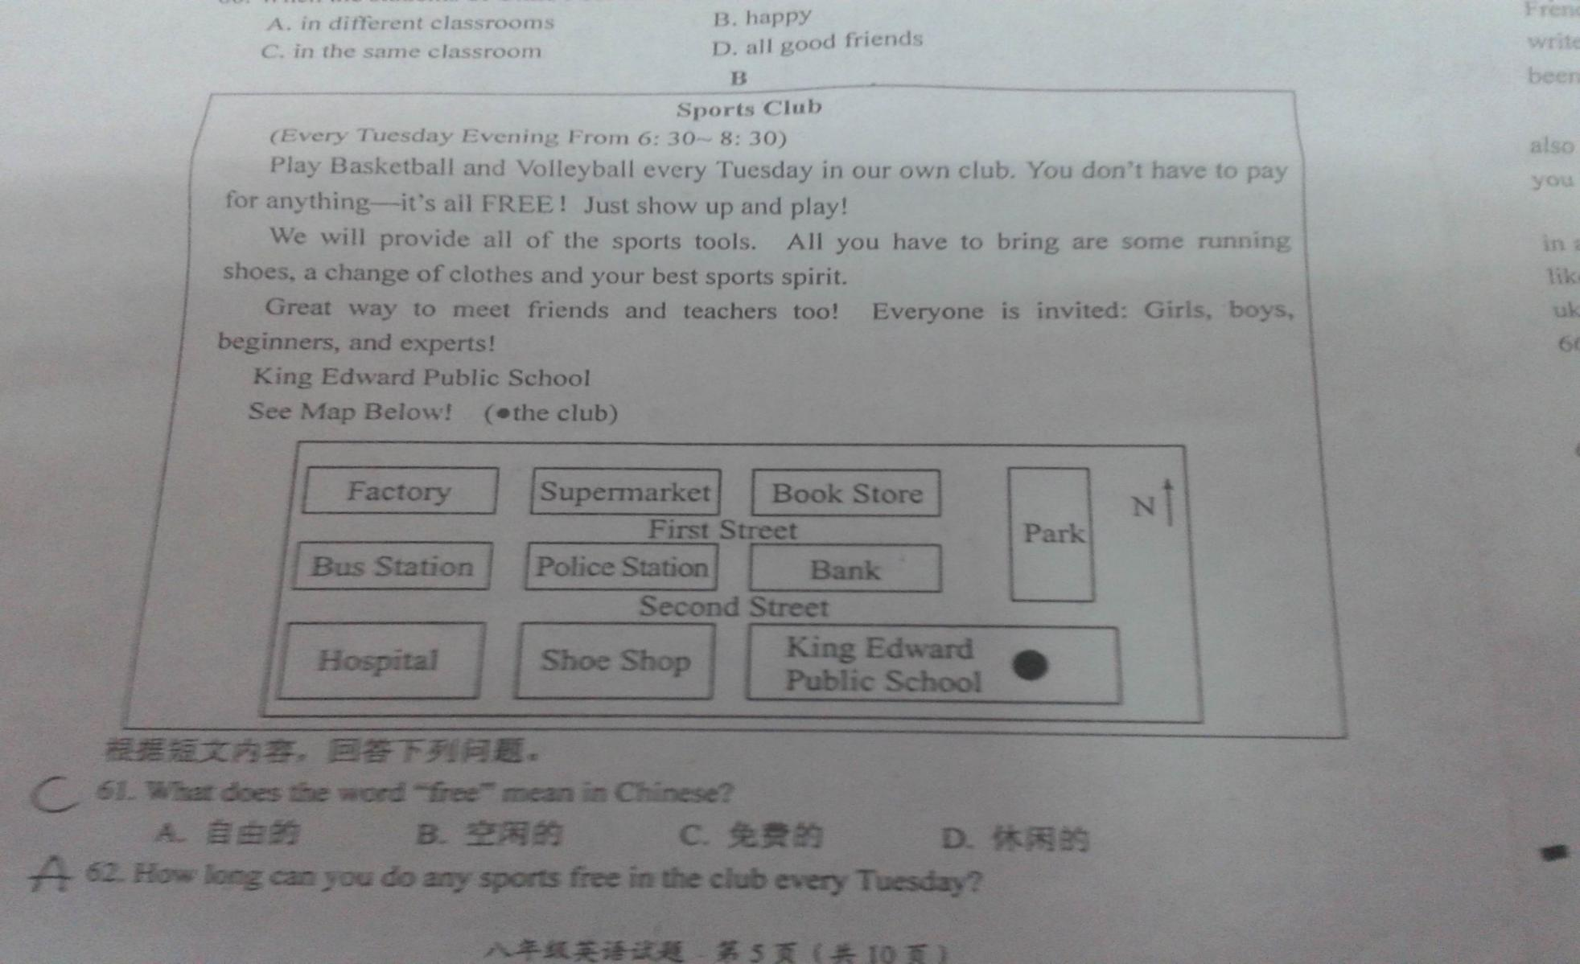

*61. What does the word ‘free’ mean in Chinese?*

*A. 自由的 B. 空闲的 C. 免费的 D. 休闲的*

*62. How long can you do any sports free in the club every Tuesday?*

*A． For 2 hours B. For 3 hours C. For 1 hour D. For 1.5 hours*

*63. What do you have to bring when you play games?*

*A. Some money B. The sports tools C. Some water D. A change of clothes*

*64. Who can you meet in this club?*

*A. Friends and teachers B. Friends and parents*

*C. Parents and teachers D. Parents and classmates*

*65. Could you tell me the way to the club?*

*From the gate of the bus station, walk along First Street and ______ at the third turning. At the end of the street, you’ll find King Edward Public School. The club is in it.*

1. *turn left B. turn right C. go on D. walk past*

*C*

*I am Steve. I was born in South Wales. My favorite place to play was out on the hills where my imagination had much space(空间) to expand(拓展).*

*We moved out of Wales when I was 13. I went to a new school. One of my subjects was French. Because I had never learned any French, my teacher told me to sit in the corner and write anything I was interested in. That is the time I started writing, just for myself, and I have been writing ever since.*

*I have always loved BIG IDEAS, and so I enjoyed writing fantastic(奇异的) stories. And I also write horror(恐怖的) stories. I think they are like the old fairytales(童话), and can teach you important things.*

*I am in my forties. I like rock music, Indian and Chinese food, and I enjoy drinking. I live in a small village with my wife Mary, ducks, cats, goats, hens and lots of rabbits. If you would like to find out more about me and hope to buy my books, go to www. Sbowkett. Freeserve. co.uk*

*66. When the writer was 13, he ______.*

*A. wrote poems B. moved out of Wales C. sold story book D. became a writer*

*67. He liked playing out on the hills because he could ______.*

*A. expand his imagination B. learn French C. listen to stories D. buy some books*

*68. Maybe the writer is _____ years old now.*

*A. 12 B. 22 C. 32 D. 42*

*69. According to the passage, the writer keeps _______.*

*A. cats, hens and pigs B. ducks, goats and rabbits*

*C. hens, rabbits and dogs D. rabbits, pigs and cats*

*70. From the passage, we can learn that the writer _______.*

*A. lives in a big city with his son B. likes eating Japanese food*

*C. lives in the countryside with his wife D. write a new book to us*

1-5 ADBCD 6-10 CCDAC 11-15 BCABC 16-20BBBAA

46-50CADCB 51-55ABDDA

56-60DCCDA 61-65CADAB 66-70BADBC