Lesson 1 Back to School
Class： Name： Group：____________
Learning Aims【学习目标】
1.通过音标拼读，能够掌握课标要求的“四会”词汇： physics recent；
2.通过课文对话表演和小组讨论，能够用英语谈论八年级的第一天；
3.通过小组合作，能够进一步了解和掌握简单句的构成。
Key Points and Difficulties【重点难点】
重点：（1）词汇： physics, recent
- 短语：One... and the other... introduce...to...
难点：（1）句型：How do you like the first day of a new term/school year?
I was happy to see my classmates after such a long holiday.
I wanted to talk to Sandra, but I didn’t know to begin.
Well, you can introduce yourself to her.
I like the one of you on the camel.
（2）语法：掌握简单句的基本构成。
Learning Process【学习流程】
A. Self-learning
I. 知识链接
Read the words and expressions of Lesson1 on P131 & P142.
II. 基础感知
Listen to the dialogue between Li Ming and Danny, and fill in the blanks.
Yay! I am in Grade 8!
 | I was happy to see my classmates after such a long __________.  I have two new classmates this term. One is Sandra and the _______ is Mary.  We also have a new __________ teacher. Her name is Ms. Cox.
 | We have a new subject this term-- ___________.  Tomorrow we will make a class picture, but I don’t have any good ________ pictures of myself.
III. 攻坚克难
1. Read the dialogue and answer the following questions:
(1) What advice does Li Ming give Danny on how to start a new conversation with Sandra?

(2) What will Li Ming do to prepare for his class tomorrow? Why?

2. P3 Exercise2 Listen and tick the correct pictures.
My notes:

3. P3 Exercise 4:
Read and then write a short passage.
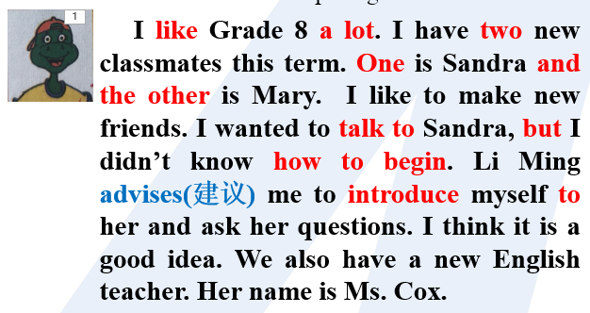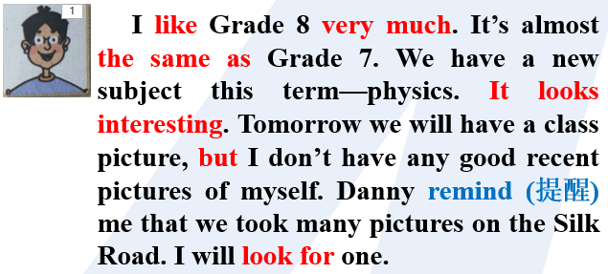
How do you like Grade 8?
What is new this term?
Are there any new students or teachers in your class? Introduce them.
Do you have any new subjects? What are they? What will you do to learn them well?

IV. 探究未知：Difficulties and Questions.

- Group-learning（群学）
- Discussion:
(1) Pair work: Read the dialogue on P2 and discuss Exercise 1 on the paper.
(2) Group work-- P3 Exercise 4: Share your passage.
2. Presentation

