|  |  |
| --- | --- |
| 长城学校初中部初备教案 | |
| 姓名： 高君晔 年级： 七年级 学科： 英语 集备时间： 2021.4.16  课时： 1 课型： 新授课 课题： Lesson 28 How do I Learn English? | |
| 课标 学情分析 | 本单元围绕“打电话”展开教学。围绕“用英语打电话”、“如何学英语”与“谈论英语的重要性”的话题编排,教材为学生提供了表达用英语打电话、学习英语及英语单词和谈论英语的重要性,帮助学生学习这些场景中需要的英语表达方式。第28课内容讲述了学习英语的技巧和方法:多阅读和使用字典, 读英语故事、杂志和报纸,遇到不认识的单词要查字典。看英语电视节目和电影可以集学习和娱乐于一体。听英语音乐,背英语歌词对英语学习非常有用。每天坚持说英语,不要怕犯错误。话题简单，激发学生兴趣，贴近学生生活。通过本次课的学习，达到以下大纲要求：  1.学会使用单词和习惯用语或固定搭配；  2.围绕话题恰当理解与运用相关的语言表达形式；  3.根据不同的阅读目的，运用简单的阅读策略获取信息。 |
| 学习目标 | 1. 通过自然拼读，掌握新课标要求的“四会”词汇magazine, newspaper, mistake, silly；   2. 通过回答问题，能够捕捉本课大致的信息如Teresa学英语的基本情况；  3. 通过思维导图进行文本复述，能够Teresa的具体细节;  4. 通过小组合作，能够用介绍自己如何学英语。 |
| 重点难点 | 重点： 1. 识记Lesson 28重点的单词词组。  2.掌握和运用关于英语学习方法的句型:  I came to Canada two years ago.  How do I learn English?  Read a lot and use a dictionary!  So I look them up in a dictionary.  Watch English TV shows and movies!  I can enjoy myself and learn English at the same time.  Listen to English music!  I like to write the words down.  Speak English every day!  Don’t be afraid to make mistakes!  Sometimes I make silly mistakes and I laugh at myself.  Can you ask him to call me later?  难点：能使用一般现在时、一般过去时、一般将来时和祈使句。 |

【教学流程】

1. 导学

Do you like English? Why? Why not?

How do you learn English?

二、独学

1. 知识链接

Words and expressions of Lesson 28.

1. 基础感知

Task 1. Fast Reading.

When did Teresa go to Canada?

What grade is Teresa in?

Where does her family come from?

What language does she speak at school?

How many tips does Teresa have when she learns English?

(1) Read a lot and use a dictionary!

(2) Watch English TV shows and movies!

(3) Listen to English music!

(4) Speak English every day!

Task 2. Read the text and try to retell the passage.

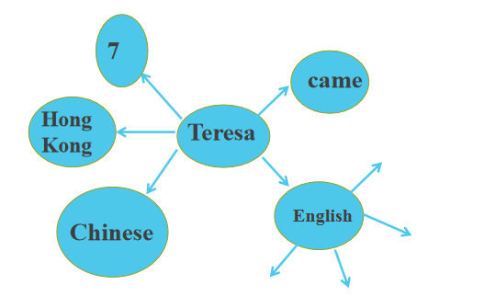

Task 3. How do I learn English?

Tips:

(1) read, use, storybooks..., don't understand, look them up

(2) watch, evening, enjoy, learn

(3) listen,love, go, find, write, sing along

(4) speak, practice, don't be afraid, sometimes, help

1. 重难点突破

Task 4. How do you learn English?

1. 探究未知

We can learn English in many ways

What are they?

三、群学

1. 群学-议

两两合作解决：知识链接，Task1,2,3

小组合作解决：重难点突破

1. 群学-展示

1. 知识链接：找中下层学生回答问题，纠正读音 3个学生

2. Task 1-3 一人一句

3. 回答问题，并让其余学生订正。

4. 重难点突破，至少3个。

四、概评

1.So I look them up in a dictionary.

根据上句，本句 look up 译为_______，指查找与文字信息相关的资料，用名词或代词作宾语.

eg. (1)Please look up his phone number. =Please look his phone number up.

(2) I don’t know the meaning of the word, I’ll look it up in a dictionary.

从例句中我们可看出，look up（动副词组） 的宾语是名词时，放在look up的_______；其宾语是代词时必须放在它的_____.

2. I can enjoy myself and learn English at the same time.

译：_______________________.

他们同时完成了作业。

3.I practice my English in class and after class.

译为：________________.

in class 意为 “______” ,after class 意为“ _______” 。

4.Don't be afraid to make mistakes .

译为：____________.

其常用结构:

a)害怕做某事______________.

我害怕在同学们面前说话

b) be afraid of sth. 害怕某物

5.Sometimes I make silly mistakes and I laugh at myself .

laugh at 意为“_______”

e.g. Everyone laughed at Jim but Lily didn't.

It's not polite (礼貌的）to laugh ____others.

五、检改

（1）学生自行回顾本课知识（1min）

（2）Help Jimmy !

Jimmy is very bad at English, he’s worried about that, please give him some good suggestions to help him.

【复备改进】

【板书设计】

Lesson 28 How Do I Learn English?

in/after class, make a mistake/mistakes,

be afraid to do…, look up, laugh at,

right now, enjoy oneself

I came to Canada two years ago.

How do I learn English?

Read a lot and use a dictionary!

So I look them up in a dictionary.

Watch English TV shows and movies!

Listen to English music!

【课后反思】