Lesson 1 Back to School
Class： Name： Group：____________
Learning Aims【学习目标】
1.通过音标拼读，能够掌握课标要求的“四会”词汇： physics recent；
2.通过回答问题，了解课文；
3.通过小组合作表演对话，训练学生的课文朗读及表达能力。
4.通过读文章写一篇自我介绍的小短文，练习学生的写作能力。
Key Points and Difficulties【重点难点】
重点：（1）词汇： physics, recent
- 短语：One... and the other... introduce...to...
难点：（1）句型：How do you like the first day of a new term/school year?
I was happy to see my classmates after such a long holiday.
I wanted to talk to Sandra, but I didn’t know to begin.
Well, you can introduce yourself to her.
I like the one of you on the camel.
（2）语法：掌握简单句的基本构成。
Learning Process【学习流程】
A. Self-learning
I. 知识链接
Read the words and expressions of Lesson1 on P131 & P142.
II. 基础感知
Task 1.Listen to the dialogue and repeat.
III. 攻坚克难
Task 2. Read the dialogue and answer the following questions:
(1) How many new classmates does Danny have? What are their names?

(2) What advice does Li Ming give Danny on how to start a new conversation with Sandra?

(3)Li Ming has a new subject this year. What is it?

(4)What will Li Ming do to prepare for his class tomorrow? Why?

Task 3. Role play:work in pairs.One is Li Ming, and the other is Danny.
Task 4. P3 Exercise 4:
Read the passage , then according to the questions below, write a short passage.
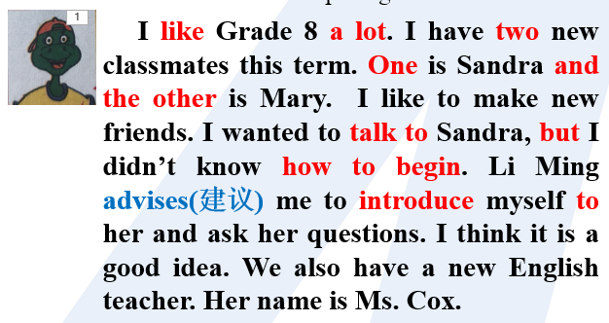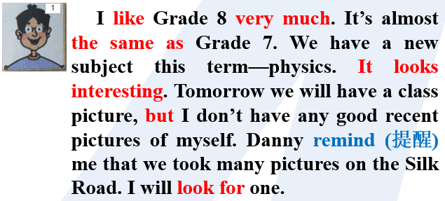
Opening：Today is my first day of this new term.I like Grade 8 a lot.I find a few changes between last term and this term/I find it is almost the same as Grade 7....
What is new this term?
Are there any new students or teachers in your class? Introduce them.
Do you have any new subjects? What are they? What will you do to learn them well?
Closing: I am happy to go back to my school.....

IV. 探究未知：Difficulties and Questions.
- Group-learning（群学）
- Discussion:
- Pair work: Task 2 :Read the dialogue on P2 and discuss Exercise 1 on the paper.
Task 3 :Practice Exercise 2 on the paper.
(2) Group work-- P3 Exercise 4: Share your passage.
2. Presentation
一．重点短语
做...很高兴 be happy to do sth. 这么长的假期such a long holiday
这么多有趣的书 so many interesting books 一个...另一个... one...the other...
再两天 another two days 近期我自己的照片recent pictures of myself .
我不知道如何开始.I don’t know how to begin. 和...相同 be the same as
结交新朋友 make new friends 介绍自己给... introduce myself to..

- 重点知识点
1.主语+be +adj. + to do sth.
sb. be happy / sad /glad/sorry/surprised/to do sth.
2.such adj. 这样的；如此的;修饰名词
so adv. 这样的；如此的;修饰形容词或副词
两种特殊情况
such+a/an+形容词+可数名词单数=so+形容词+a/an+可数名词单数
当名词前有many，much，little （少）few 等词修饰时，用so ，不能用such.
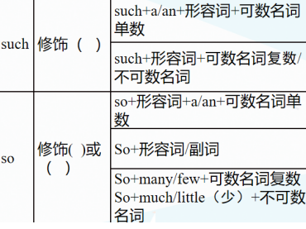

3.one ...the other... (两者中)一个...另一个
another 另一又一（指三者或三者以上中的另一个）
another+名单 another +基数词+名复=基数词+more+名复
Eg: another two days=two more days
4. introduce A to B 把A介绍给 B
introduce oneself 自我介绍
5.how to begin属于"特殊疑问词+动词不定式"结构,在句中作know的宾语“特殊疑问词(why除外) +动词不定式"结构在句中可以作know，tell, wonder, ask, learn等动词的宾语,也可以作主语或表语。

