LESSON PLAN
蔺勤荣
Unit  5 | Lesson  28 | Topic  L28Our Ambitions and Dreams | Date  Oct.26th

Personal TP aim(s):
To monitor straight after instruction to check if Ss are on task or if they need help.

Main lesson aim(s):
By the end of the class, Ss will Ss will have developed their reading skills on specific information
Subsidiary lesson aim(s):
By the end of the class, Ss will Ss will have developed productive sub-skill of speaking on the topic of a present

Page yearbook airplane pilot fear height overcome model

Stage / Time  (What you are doing.) | Aim  (Why you are doing it.) | Lesson Procedure  (How you are doing it – including target language, instructions, concept questions, answers to tasks etc., where appropriate.) | Interaction / Resources  (e.g. ss-ss, t-ss, etc. and what you are using.) | Tutor Comments
Lead-in  5min | To introduce the topic and draw interest | What does it mean to know yourself?  How well do you know yourself? | T-Ss  Ss-T
Gist reading&Specific Reading | To read for gist information of L20 | Task1:  1. Listen to the passage and fill in the blanks.  1) Li Ming and his classmates are talking about their ambitions and __________.  2) The main thing is to know _______ and to choose the right path for you.  3) Ms. Liu is ________ with her students.  4) What is Danny going to be when he is ______.  5) Danny is good at playing _____________. | Ss  Ss-T
Detail reading | To read for gist information of L20 | Task2:  Read the lesson and answer the questions in Ex1 on Page75.Task3:Read the passage and fill in the blanks and try to retell.  Task 3: Circle write down the comparative and superlative adjectives in Unit 5.  圈出并写下本单元课文中涉及到的形容词的比较级和最高级。  ___________________________________________________________________ | T-Ss  Ss-T
Specific Reading |  | 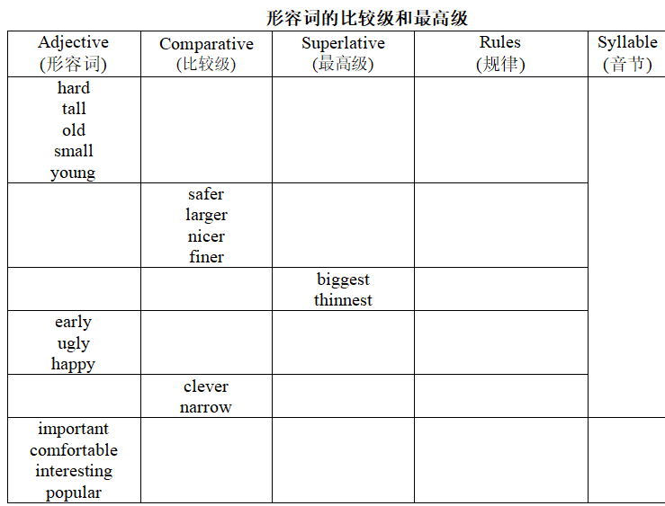
Freer Practice | To develops Ss’ skills of describing your neighbourhood. | 比较级和最高级的特殊用法 | T-Ss  Ss-T  Ss-Ss  Ss
SUMMARY |  | ambition /æmˈbɪʃn/ n.抱负；雄心 fisherman /ˈfɪʃəmən/ n.渔夫；渔民  policewoman /pəˈliːswɪmɪn/ n.女警察 artist /ˈɑːtɪst/ n.艺术家  choice /tʃɔɪs/ n.选择 path /pɑːθ/ n.途径；小道  strict /strɪkt/ n.严厉的；严格的 punish /ˈpʌnɪʃ/ v.惩罚；处罚  1.clear goals明确的目标  2.so many good choices如此多的好选择  3.choose A from B 从B中选择A  4.be strict with sb. 对某人严格  5.some......others..... 一些...另一些
Writing on the Blackboard

