Lesson 36 Clean Cars?
班级: 姓名: 小组:____________
【学习目标】
1.通过听力选答案，了解李明和詹尼邮件话题-transportation；
3.通过回答问题，对李明和詹尼提到的绿色交通有所认识；
3.通过文本填空，
4.通过小组合作，能说出不同交通工具的优点和缺点。（难点）
【重点难点】
重点： 掌握有关于环保交通工具的单词和表达方式。
难点： 能够向大家介绍一下交通工具的利弊之处，如何让交通工具更环保。
Learning Process【学习流程】
II. 基础感知
Task1: Listen and tick the correct answers.E1P93

Task 2: Read the text again and answer the following questions.
- What did Jenny's class do this week in school?
______________________________________________
- What did the teacher ask the class to do?
______________________________________________
- What does Li Ming think of Jenny’s idea of inventing a clean car?
______________________________________________
- What does Li Ming think of cars?
______________________________________________
- How did Li Ming travel around the city?
______________________________________________
- How long did Li Ming pedal?
______________________________________________
7. What will cars use to power them in the future?
______________________________________________
III. 攻坚克难
Task 3: Fill in the blanks with the correct forms of the words and try to retell.
This week, Jenny’s class discussed_______________(交通).They ________(learn) about trains, planes ,rockets and more. The teacher asked them to think ______ the future of transportation. They had to think of ___ invention and present it ____ the class. Danny ______(give) a very interesting ____________ (present). He put _____ an old backpack. He _____(get) on a chair and ________ (jump) down. He wanted to fly.Li Ming thinks that cars are bad _____our environment. When people walk or ride bicycles more often, our air would be a lot _______(clean). He _________(pedal) for more than an hour! In the future, cars will ________(probable) use water or sun energy to power them.
Task 4: What are the advantages and disadvantages of different types of transportation? Talk with your partner and fill in the table.
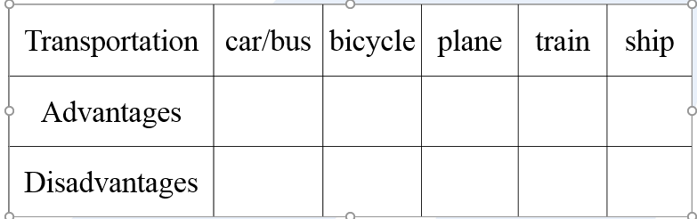
Useful expressions: speed, cost/price, time, fuel, be good for, faster than…
fast /slow expensive /cheap, comfortable, clean, easy to carry / drive / park , convenient, exciting, hold more people,
be good for health / environment , environmental, save time, ...
Useful Expressions【常用表达】
(1) 词汇：pedal, than, energy
(2) 短语：from now on, think of, jump down, more than
(3) 句型：We had to think of an invention and present it to the class.
He got on a chair and jumped down.
That sounds like a fun project!
They are very bad for our environment.
I hope your presentation goes well.
考点驿站：
1. What different kinds of fuel may be used in the future?
be used 被用 Wood is used to make paper.
be used to do 被用来做某事 A dictionary can be used to check the words.
2.What types of transportation will people use a hundred years from now on?
from now on 从现在起
From now on I will try to do better.
3.The teacher asked us to think about the future of transportation.
ask sb. to do sth. 叫（要求）某人做某事
类似用法的动词：tell, want, allow, wish, teach, advise, encourage
否定结构：在不定式to符号前加not。
My mother told me not to play on the road. It’s dangerous.
妈妈告诉我不要在马路上玩耍，很危险。
4.That sounds like a fun project!
sound系动词，表示“听起来，似乎”，sound like 表示“听起来像……，似乎……”。Your voice sounds like the singing birds.

