L34：Flying Donuts
班级: 姓名: 小组:____________
【学习目标】
- 借助音标和跟读单词，能够正确读出四会词汇
- 通过边听边跟读文本，能够初步了解文章，回答问题。
- 通过细读课文，能够获取文本关键信息，回答问题填空；
- 通过小组合作及讨论，能够想象一个未来交通方式并进行简单描述。
【重点难点】
重点：单词invention,oil,probably短语stay up late,turn on等
难点：介绍一个想象的未来交通方式。
【导学流程】
Lead-in
What is “flying donuts”? Does it mean “donuts flying in the sky”?
A. Self-learning
一、知识链接
Read the key words according to the phonetic marks.
二、基础感知
Task 1:Listen to the passage and read after the audiotape．
What is“flying donuts”?
____________________________________________________________________________.
What is it made of ?
____________________________________________________________________________.
三. 攻坚克难
Task 2: Read the text quickly and answer:
1）How did he make it?
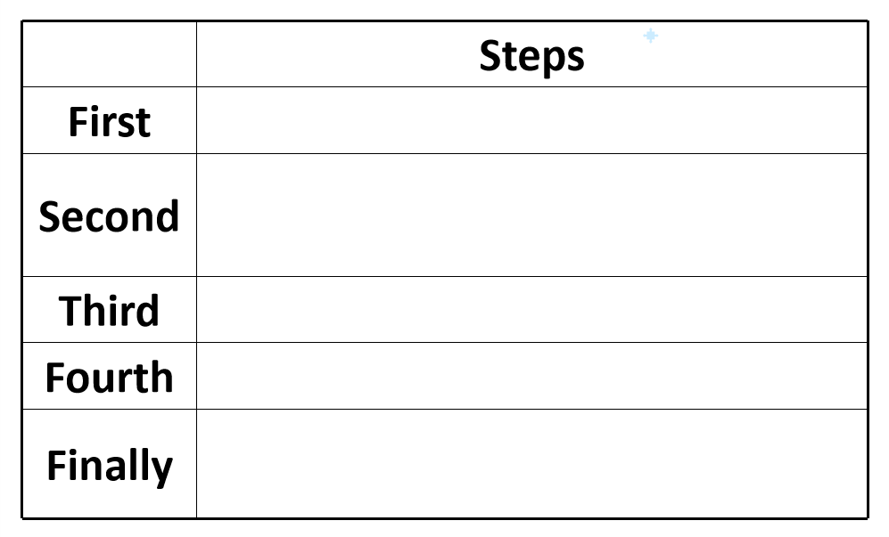
2）How did Danny use his invention?
____________________________________________________________________________.
Task 3: Read carefully and answer the following questions.
- What do the donuts do?
____________________________________________________________________________.
- How far can his invention fly？
____________________________________________________________________________.
- Why are donuts best to Danny?
____________________________________________________________________________.
- Do you think Danny’s invention really work?
____________________________________________________________________________.
Task 4: Fill in the blanks and retell according to the verbs:
Danny has thought of a new kind of transportation. He wants to give a ________ on it to the class. Last night, he stayed up late to make his ______.He took an old__________. Then he made two _______rockets. He painted them red and glued them onto the backpack. In the morning, on his way to school, he bought ten donuts. They are the _____. He didn't use ____ or coal. This is his new invention. He used his ________. Will Danny's invention really work?________ not.
四、探究未知
Task 5: Imagine a future transportation.
- Draw a simple picture of your future transportation.
- Give a name to it.
- Describe the following tips.
1）What is it made of ?
2）How do you make it?
3）How do you use it ?
4）What’s the fuel of it？
（风能wind energy水能Hydro energy太阳能solar energy天然气natural gas电能 electricity 汽油petrol......）

____________________________________________________________________________
____________________________________________________________________________
____________________________________________________________________________
____________________________________________________________________________
____________________________________________________________________________

背诵
单词： presentation n. 介绍；陈述
invention n. 发明；创造 invent v．发明inventor n．发明家
backpack n. 背包
cardboard n. 硬纸板
fuel n. 燃料
oil n.油；石油
probably adv. 大概；很可能；也许
imagination n. 想象；想象力

短语： 1. stay up late to do 熬夜做某事
2.glue ...on to 把...粘到
3.turn on/off/up/down 打开/关上/调高/调低
4. jump into 跳进
5. get hungry 变得饥饿
6.think of 记起，想起
7. give a presentation 做展示
8. in/at the front of 在内部前面
句型：
- Last night,Danny stayed up late to make his invention.
- First,you put the Flying Donuts bag on your back.
- Then you turn it on and jump into the air!
- To go ten kilometres, you need ten donuts.

