LESSON PLAN
Unit  7 | Lesson  38 | Topic  L38 | Date  Nov.25th

Personal TP aim(s):
To monitor straight after instruction to check if Ss are on task or if they need help.

Main lesson aim(s):
By the end of the class, Ss will Ss will have developed their reading skills on specific information
Subsidiary lesson aim(s):
By the end of the class, Ss will Ss will have developed productive sub-skill of speaking on the topic of a present

Thirteen tape post yet address top stamp

Stage / Time  (What you are doing.) | Aim  (Why you are doing it.) | Lesson Procedure  (How you are doing it – including target language, instructions, concept questions, answers to tasks etc., where appropriate.) | Interaction / Resources  (e.g. ss-ss, t-ss, etc. and what you are using.) | Tutor Comments
Lead-in  5min | To introduce the topic and draw interest | What types of hobbies can you think of?  Teacher shows some hobbies to the students. | T-Ss  Ss-T
Gist reading | To read for gist information | Task 1:  Listening! Ex2 on P101.  ____________________________________ | Ss  Ss-T
detail Reading |  | Task 2:  Read the passage after the audiotape to correct your pronunciation.
Specific Reading | To read for specific information | Task 3. Task1: Read the passage quickly and complete Ex1 on P101.(instructions指示)  Task4: Answer the questions below according to the passage.  1. Why is a hobby useful?  _________________________________  2.How many types of hobbies are mentioned in the text? What are they?  _________________________________  3. When do people usually take up their first hobby?  __________________________________ | T-Ss  Ss-T
Freer Practice | To develops Ss’ skills of analysising the situation of in the library. | 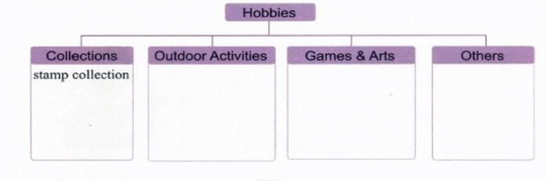 | T-Ss  Ss-T  Ss-Ss  Ss
Quiz |  | E
Writing on the Blackboard | 1.不但……而且…… not only...but also...  A hobby is not only fun but also useful.  2.开始从事 take up  People usually take up their first hobby when they are kids.  3.一些……另一些…… some...others/other+可数名词复数...  Some people like to collect things such as stamps, such as stamps, toy cars and postcards. Other hobbies are outdoor activities.  4.收集东西 collect things  (collect stamps集邮, collect toy cars收集玩具汽车, collect stones收集石头，collect leaves收集树叶)  5.户外活动 outdoor activities  (travelling旅游,skiing滑雪,gardening园艺,mountain-climbing爬山)  6.It’s never too late to learn something new.  7.A happy child has a hobby.  8.All work and no play makes Jack a dull boy.  9.Happy is the man who is living by his hobby.  10.If you have time after work for your hobby, you are lucky. But if work itself is a hobby for you, you are luckiest.

