Lesson 33 Let’s Go to the Zoo!
班级: 姓名: 小组:____________
Learning Aims【学习目标】
- 通过自然拼读，掌握新课标要求的“四会”词汇：
dream,noise,lion,lonely,miss,forest,course.
2. 通过阅读课文，能够了解本课中动物们的情感和正在进行的动作。
3. 通过阅读练习，能够听懂文章并且能够对文章内容进行填空；
4. 通过小组对话合作，根据文本进行角色扮演，提高口语表达能力。
5. 通过观看视频，能够认识到保护动物的意义。
Key Points and Difficulties【重点难点】
重点：1.掌握单词：dream,noise,lion,lonely,miss,forest,course.
短语：go to the zoo, make noises, of course.
2.掌握一些与介绍动作有关的词汇：eat, sleep,dream, make, sing.
3.掌握以下重点句子：
They are making noises.
Maybe he is missing the forest.
Do animals have feelings?
难点：激发学生兴趣，能够利用所学知识介绍动物园中动物的动作。
Learning Process【学习流程】
Step 1：Let’s guess what animals it is?
Step 2：Read the passage for the first time and answer the following questions.
1、How many kinds of(种类) animals in the zoo？
There are_____________________________.
2、What are they？
They are _____________________________.
Step 3：Read the passage for the second time and answer the following question.
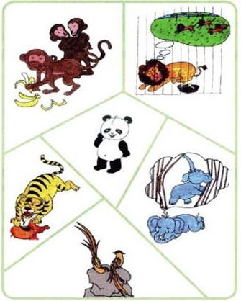
What are the animals doing?
1.
2.
3.
4.
5.
6.

Step 4： Let’s play a guessing game. (One student do action(做动作，行为), and other students try to guess what is he/she doing?)

Step 5：Read the passage for the third time and fill in the table（表格）.

animals | actions(动作或行为) | feelings(情感)
tiger | eating meat
birds |  | happy
lion | missing the forest

Step 6：Talk with your group members（小组成员） about your favourite animals and write something down. You can also write some other things（可以进行扩展）

Tips（提示）
My Favourite Animals

My favourite animal is …
It has… (What does it look like? )
It likes to … (What does it like to do?)
It often eats…
It lives in/on…
Look! It is … (What is it doing?)
.
Animals food
meat bamboo（竹子）
bananas worm（虫子）
fish grass(草)
fodder（饲料）

Animals place（动物居住地）
forest（森林） home
cave（洞穴） zoo（动物园）
tree sea（海）
river

Step 7： Let’s enjoy a video together and try to think about these two questions.

- Do animals have feelings (情感)?
_____________________________
2、What should we do for animals?
_____________________________

晨读内容：

I. 32课词
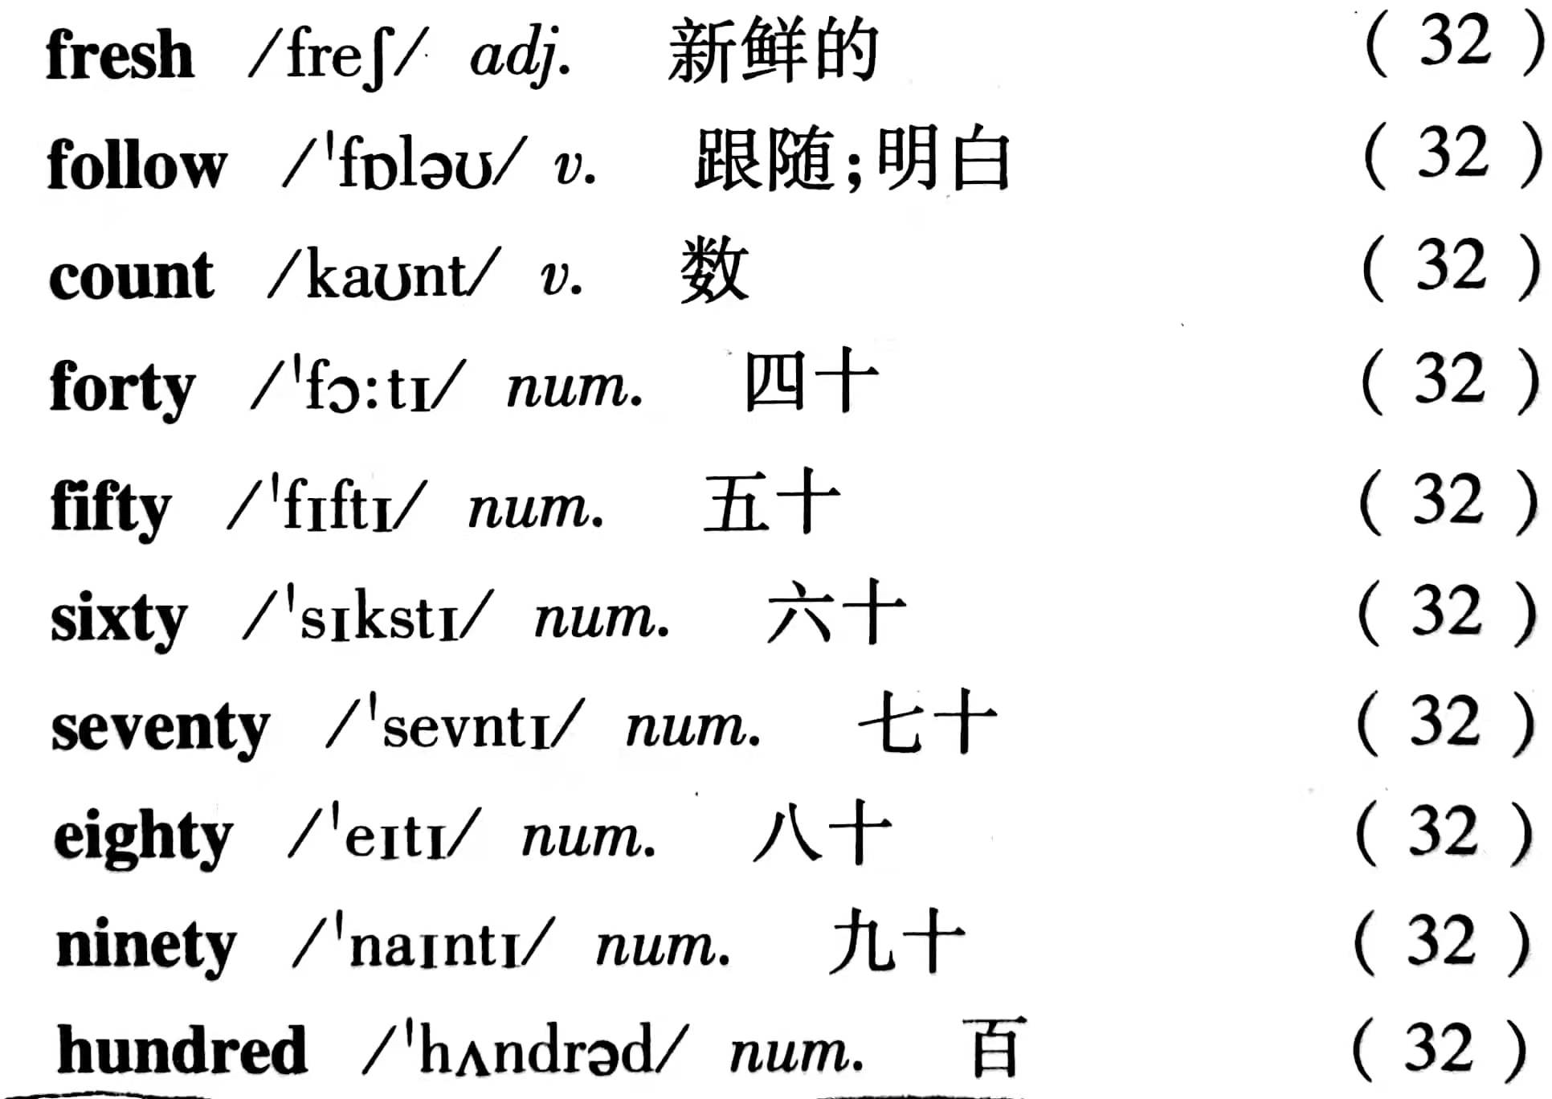

II.第32课A Family Picnic 课文背诵

III、读背以下知识点：

1.Li Ming and his mum are shopping at the supermarket.李明和他的妈妈正在超市里购物。
go shopping去购物
- Mrs. Li wants to buy some fresh vegetables李夫人想要买一些新鲜的蔬菜。
buy〔及物动词〕买,
常用短语buysb.sth.=buy sth.forsb,意为“给某人买某物”。
fresh 〔形容词新鲜的,清新的
fresh vegetables意为“新鲜的蔬菜”。
3.I am looking for the potatoes. 我正在寻找土豆。
potato〔可数名词〕复数形式是potatoes。
以o结尾复数加-es的名词“英雄爱吃西红柿炖土豆”(hero)(tomato)(potato) (-es)
4.They are next to the carrots. 它们在胡萝卜旁边
next to 紧邻;挨着可用 close to 或 beside 替换。
He sits next to me.他坐在我旁边。
5.I’ll show you.或Let me show you,我来指给你看。
show ①〔及物动词〕带领,引导,指出,展示
show sb. sth. 等于 show sth.to sb., 意为“向某人展示某物;给某人看某物”
Show him the way.给他指路。
6.Please follow me.请跟我来。
follow 跟随,追随
沿着,顺着……走
明白,听懂，理解(understand)
7.I will take it.……我买(这件)了
I will take... 我买……
其中take 意为“买”,相当于buy, get或have。在口语中,当顾客选定商品，决定购买时，通常说“I will take it.”。
8.one hundred 一百
hundred 〔数词] 百
hundred 前有具体数字修饰时,不加-s,通常不与 of连用。
hundreds of 意为“成百的，数以百计的”，后跟可数名词的复数形式。

选背部分IV、大声读背新概念Lesson79 Carol’s shopping list.

