Lesson9&Lesson 10 Review
Class： Name： Group：

Learning Aims【学习目标】
- 通过回顾单词与短语，能够掌握since, cough, because,seem, rush等四会词汇及重点短语。
- 通过阅读课文，能够找出并勾画出现在完成时句子并掌握一般疑问句的转化。
- 通过听力练习和现在完成时的练习，能够巩固现在完成时的用法和时间的读法。
- 借助小组合作，能够设置情境与他人约定时间去做某事。
Key and Difficult Points【重点难点】
重点：1. L9&L10重点单词及短语
- 总结现在完成时的句型结构及用法。
难点：用英语与他人约定时间去做某事。
Learning Process【导学流程】
- Self-learning
- 知识链接
1.Read the two lessons and underline the present perfect tense.
2. Rewrite the sentences into questions.
① I have been sick for two days.
________________________________________________________
② I have downloaded some pictures of Beijing.
_________________________________________________________
- 基础感知
Listen to the conversation and questions, and then choose the correct one.
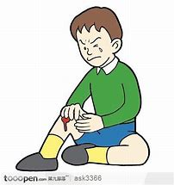
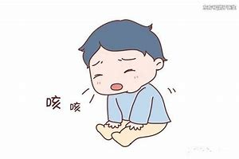

- What was the matter with the boy?
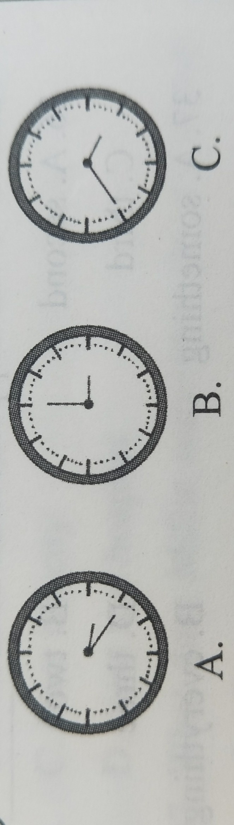
- What’s the time now?
C.
B.
A.
- What class does Danny have this morning
A. Chinese and maths. B. English and maths. C. English and Chinese.
4. What does Danny think of Mr. Cox？
A. He is kind. B. He is strict. C. He is knowledgeable.
III.攻坚克难
Task 1: Fill in the blanks using correct forms.
- Mark ________ (live) in Shijiazhuang for about ten days.
- My mother was cooking dinner when I _______(get) home from work.
- You _______ (grow) since the last time saw you.
- I __________ (not, finish)my homework yet. I am afraid I can't go to the park with you.
- When I was a child, my grandmother often ________ (take) me to the zoo.
- Mr. Smith will call me when he ________ (arrive) here.
- I _______ (be) in Qingdao since two weeks ago.
- Li Ming has studied very hard since he _______(come )to our school.
Task2: Sentences pattern transformation.(句型转换)
- Mr. Green has worked in the hospital for ten years.（对画线部分提问）
_______ _________ _________ Mr. Green _______ in the hospital？
- I have already finished my homework.（改为一般疑问句）
______ you _______ your homework ________？
3. They came to Beijing five days ago.（改为同义句）
They ______ _______ in Beijing for five days.
4.Ms. Xie has taught English in our school since2010.（改为否定句）
Ms. Xie ______ _______ English in our school since 2010.
Task3 : Make sentences using these words.
- for, she, years, has， pet, kept, the, two
_________________________________________________________ .
- before, I, met, haven’t, them
__________________________________________________________.
- to, Beijing, ever, you, been, have
__________________________________________________________ ?
- years, this, they, since, studied, at
___________________________________________________________.
- You, when, up, will, grow, be, you, what
__________________________________________________________ ?
IV. 探究未知
Task 4: Can you make a conclusion about the present perfect tense? Make a sentence and write down the sentence pattern.
肯定句：

否定句：

一般疑问句：______________________________________________________________________________
______________________________________________________________________________标志词：______________________________________________________________________________
______________________________________________________________________________对for+一段时间或者since+时间点提问：______________________________________________________________________________

背诵目录
单词： since prep. 自……以后;从……以来 conj.因为;由于;既然
cough n. &v. 咳嗽
because conj. 因为
seem v. 好像;似乎
download v.下载
librarian n. 图书管理员
suddenly adv. 突然地
rush v. 冲，奔
into prep. 进入；到….里
shout v. 喊
whisper v& n. 低语，小声说话
quarter n. 刻，四分之一
短语： 1. miss class/school 误课/耽误上学
2.have a cough 咳嗽
3.not...at all 一点儿也不
4.be convenient for 对……便利
5.seem+adj. 好像……
6. on the computer 在电脑上（操作）
7.work on 从事；继续做
8.no noise 保持安静
句型：
1. Jenny is on the computer.
2. I have downloaded some more pictures of Beijing.
3. Suddenly the door opens.
4. Danny rushes into the library with a basketball in his hand.
5. It’s a quarter after three.
6. I haven’t seen you since Tuesday.
7. I have been sick for two days.
8. The doctor asked me to rest at home this week.
9. That’s very kind of you.
10.It seems hard, but don’t worry.
11.What time is convenient for you?
12..Physics is a headache for me.
13.I still have a cough.
14.It’s a date.

