Lesson 23:People in My Neighbourhood
Class： Name： Group：

Learning Aims【学习目标】
- 通过音标及跟读，能够识读“四会”词汇：interview, fix, tailor, sound, enjoyable,treat.
- 通过速读课文，能够了解课文大意，并找到Brian的任务及所采访的街区；
- 通过细读课文，能够提取关键信息完善有关Brain采访细节的思维导图，并进行复述；
- 通过小组合作及故事欣赏，能够介绍自己的邻居并树立团结户主邻里守望胡价值观。
Key and Difficult Points【重点难点】
重点：1. 掌握本课四会“词汇”：interview, fix, tailor, sound, enjoyable,treat等；
- 了解Brain所采访的街区人们及其生活，并在思维导图的帮助下进行复述。
难点：运用本课及所学词汇和句型，能够讨论并介绍自己的邻居。
Learning Process【导学流程】
- Self-learning
I. 知识链接
Free talk--look at the pictures in your neighbourhood and answer:
1.What is it in your neibourghhood?
2.What does she/he do? = What’s his/her job?
3.What is she/he doing?
II.基础感知
Task1: Read the passage quickly and answer.(1min)
What did Brain's teacher ask them to do?
_______________________________________________________________.
III.攻坚克难
Task2. Read quickly and complete the mind map.What places did Brian visit?(2 mins)
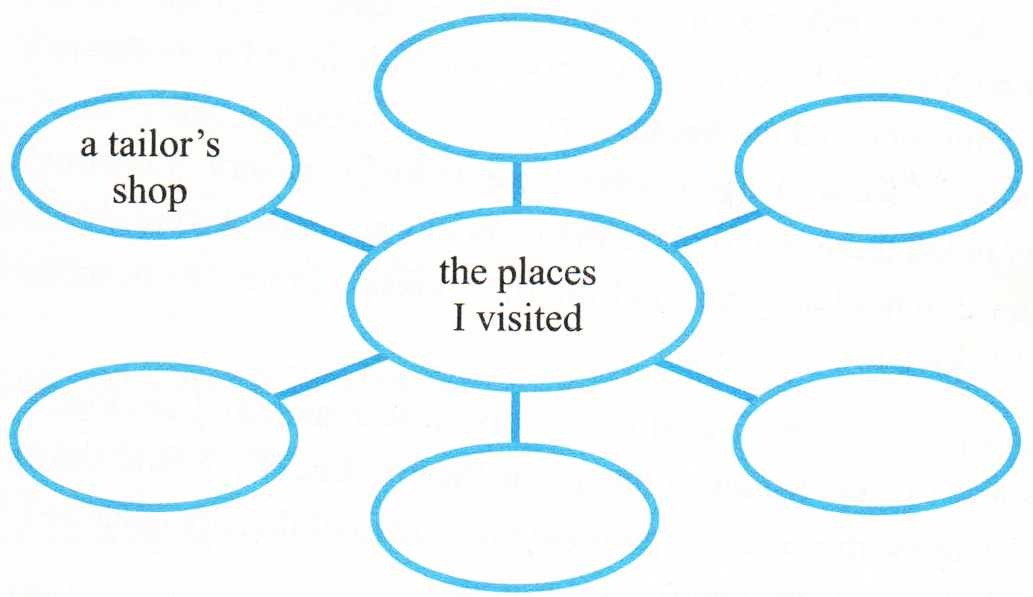

Task3. Read carefully and complete the mind map again.
I. The first stop(Para.2第2段)

II. The second stop(Para.3第3段)

III. Read carefully and answer.(Para.4第4段)
1.How were the people in Brain's nerghbourhood?
____________________________________________________.
2. How were the interviews of Brain?
______________________________________________________.

IV. 探究未知
Task4. This is Brain’s interview,how about your neibourbors? Interview someone in your neighbourhood. You can make a dialogue or make a report. Try to use the following tips.这是Brain的采访，你的邻居怎么样？采访你街区的人们，编对话或作报告。
Questions Tips(问题提示):
What does he/she look like?
What does he/she do? (job)
Is he/she young or old?
Is he/she your friend?
Is this the first time you have a talk?

Language Tips(语言点提示):
be busy doing
the smell of
be full of=be filled with
be ready by
valuable
sounds like

The Interview of My Neighbours

__________________________________________________________
__________________________________________________________
__________________________________________________________
__________________________________________________________
__________________________________________________________
__________________________________________________________
__________________________________________________________

背诵目录
单词：
interview
tailor
fix
sound
enjoyable
treat
v.& n. 面试,采访,访谈
n. 裁缝
v. 修理，维修
v. 听起来 n. 声音
adj. 令人愉快的
n. 美食，款待

/ˈɪntəvjuː/
/ˈteɪlə/
/fɪks/
/saʊnd/
/ɪnˈdʒɔɪəbl/
/triːt/

短语： 1. be busy doing sth.
=be busy with sth. 忙于（做）某事
2.sound like听起来像
3.the smell of.... ....的味道
4.be full of=be filled with充满....
句型： 1.Our teacher asked us to interview people about their jobs.
我们的老师让我们采访人们的工作。
2.He was busy fixing a pair of pants, but he still answered my questions.
他正忙着补一条裤子，但是他仍然回答了我的问题。
3.It sounds like an enjoyable job.这听起来是一个令人愉快的工作。
4.Ms. King gets up every day at 5:30 a.m. to make bread.
金女士每天早上五点半起来去做面包。
5.It is ready by 7:00 a.m.准备到7点。
6.My favourite was the smell of fresh bread.
我最喜欢的是新鲜面包的味道。
- It was warm inside and full of yummy treats.
L里面很暖和并充满了美食。
- All of them were friendly and the interviews were enjoyable.
他们很友好，采访也很愉快。

