Lesson 22:I Like My Neighbourhood
Class： Name： Group：

Learning Aims【学习目标】
- 通过音标、跟读，识读“四会”词汇：block, bank, whole, cost, chat, hockey, freeze.
- 通过听力、完成思维导图，获取Michael所住街区建筑的相关信息。
- 通过细读课文、判断正误，获取文章Michael在街区中生活的相关信息。
- 通过细化思维导图，复述Michael的街区及生活。
- 通过自己做思维导图，向他人描述自己生活的街区及生活，在实际运用中体验乐趣。
Key and Difficult Points【重点难点】
重点：了解Michael的所住街区和其生活，并在思维导图的帮助下复述其街区及生活。
难点：用英语描述自己所住街区和生活。
Learning Process【导学流程】
- Self-learning
I. 知识链接
1.Listen and fill in the blanks.
1)There is a ______ near my house. During the winter it freezes, and I can play hockey on it.
2)There's also a new shopping ________ in my neighbourhood. It's only three blocks from my house.
3)I like to go there on weekends, but I have to do some ________________ first.
4)Other times I just ______________ with my friends.
2.Read after the audiotape and mimic(模仿) it.
II.基础感知
Task1: Fast reading: Read the passage fast and complete the mind map in Ex2 on P57 on your book.(2min)
Task2: Careful reading: Read the passage carefully and complete Ex1 (T or F) on P57 on your book. Then correct the false ones.
III.攻坚克难
Task 1: What does Michael do in his neighbourhood?Extend the mind map on the right.Michael在他住的街区都做什么？请在右边扩展思维导图。
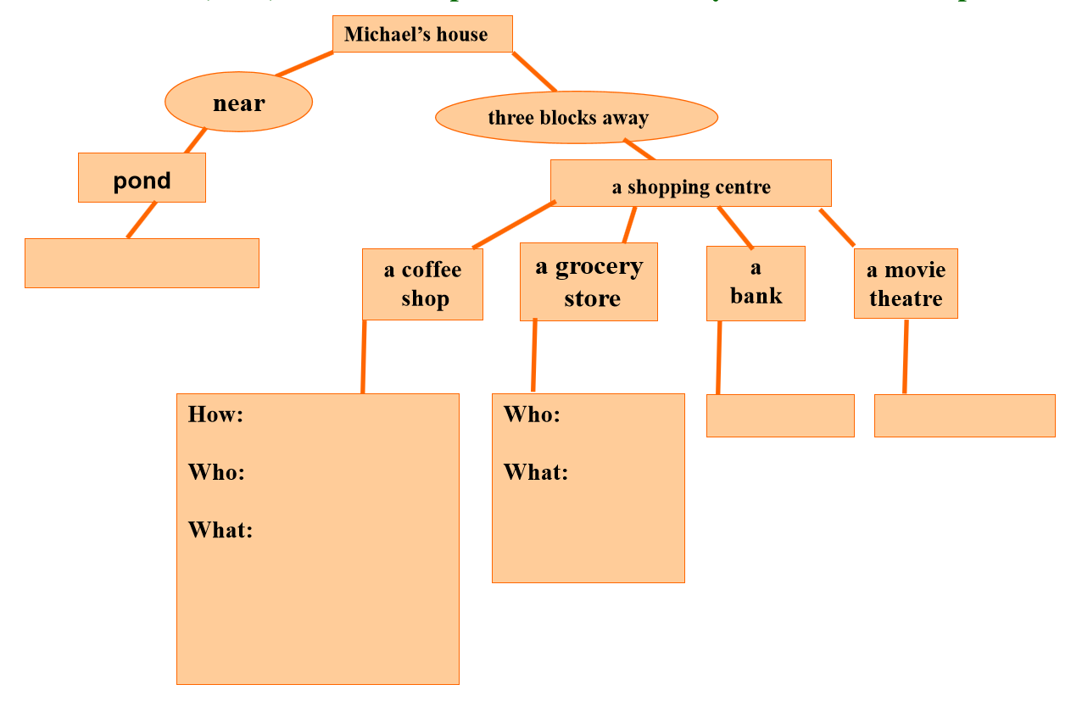

IV. 探究未知
Task4: Think about your neighbourhood. What’s your neighbourhood like? What do you like to do in it? Is there a bank, a supermarket or a hospital nearby? Draw a mind map. Then write a report to introduce your neighbourhood to others.
My neighbourhood

My Neighbourhood

__________________________________________________________
__________________________________________________________
__________________________________________________________
__________________________________________________________
__________________________________________________________
__________________________________________________________
__________________________________________________________
__________________________________________________________
__________________________________________________________
__________________________________________________________

背诵目录
单词： block /blɒk/ n.街道，栋，幢 bank /bæŋk/ n.银行
whole/həʊl/ adj.整个的；完全的 cost(cost/cost)/kɒst/ v.花费
pond /pɒnd/n.池塘 hockey/ˈhɒki/ n.冰球；曲棍球
freeze(froze/frozen)/friːz/ v.冻死；冻僵；结冰
chat/tʃæt/v.闲聊；闲谈；聊天
短语： 1.shopping centre 购物中心
2.hot chocolate 热巧克力
【a drink made by mixing chocolate powder (粉)with hot water or milk】
3. chat with...和……聊天
句型：
- There is a pond near my house.
There’s also a new shopping centre in my neighbourhood.
- During the winter it freezes, and I can play hockey on it with my friends.
- It’s only three blocks (away) from my house.
- Sometimes I sit for the whole afternoon and do my homework.
- It costs $3.50./The computer costs me 7000 yuan.
Jack spends 200 yuan on those books.
I spend two days (in) doing my homework.
How much did you pay for it?
It takes me half an hour to practice playing basketball every day.

