Lesson 38: Hobbies Are Fun!
Class： Name： Group：

Learning Aims【学习目标】
- 通过听力，复习描述他人爱好的表达、练习听力；
- 通过快速阅读，找出爱好的谚语和第二段关键句，把握文章大意；
- 借助回答问题、填表格，理清文章思路，理解文章内容；
- 借助小组合作和支架语句，描述自己的爱好及原因。
Key and Difficult Points【重点难点】
重点：1.理解课文；
2.给爱好分类；
难点：用英语描述自己的爱好以及原因。
Learning Process【导学流程】
- Self-learning
- 知识链接
Listening! Ex2 on P101.
- 基础感知
Read the passage after the audiotape to correct your pronunciation.
- 攻坚克难
Task1: Read the passage quickly and complete Ex1 on P101.(instructions指示)
Task2: Answer the questions below according to the passage.

1. Why is a hobby useful?
_____________________________________________________________________
_____________________________________________________________________
- How many types of hobbies are mentioned in the text? What are they?
____________________________________________________________________
3. When do people usually take up their first hobby?
____________________________________________________________________

- 探究未知
根据课文，将不同爱好填入相应类别的方格中。你可以加入本课以外的爱好。
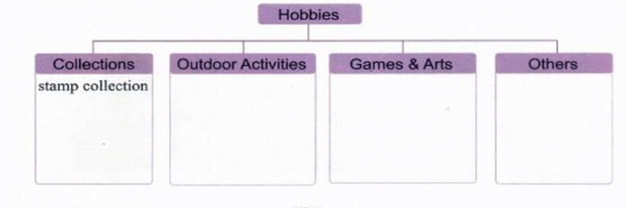

描述你的爱好的具体内容。简述你选择该爱好的原因。
___________________________________________________________________________________
__________________________________________________________________________________________________________________________________________________________________________________________________________________________________________________________________________________________________________________________________________________________________________________________________________________________________________________________________________________________________________________
confidence ∕’kɔnfidəns∕ n. 自信
postcard∕’pəustka:d∕n. 明信片
outdoor ∕’ autdɔ:∕ adj. 户外的；露天的

1.不但……而且…… not only...but also...
A hobby is not only fun but also useful.
2.开始从事 take up
People usually take up their first hobby when they are kids.
3.一些……另一些…… some...others/other+可数名词复数...
Some people like to collect things such as stamps, such as stamps, toy cars and postcards. Other hobbies are outdoor activities.
4.收集东西 collect things
(collect stamps集邮, collect toy cars收集玩具汽车, collect stones收集石头，collect leaves收集树叶)
5.户外活动 outdoor activities
(travelling旅游,skiing滑雪,gardening园艺,mountain-climbing爬山)
6.It’s never too late to learn something new.
7.A happy child has a hobby.
8.All work and no play makes Jack a dull boy.
9.Happy is the man who is living by his hobby.
10.If you have time after work for your hobby, you are lucky. But if work itself is a hobby for you, you are luckiest.

