Lesson 18：Li Ming’s Birthday
Class： Name： Group：

Learning Aims【学习目标】
- 通过音标、跟读，识读“四会”词汇：postman, balloon, candle, deep, blow.
- 通过听课文选出正确的句子，通过跟读课文，纠正自己的发音。
- 通过快读课文，纠正发音，获取文章大意。
- 通过细读课文和判断正误，获取李明过生日细节。
- 通过采访生成报告，在语境中练习描述庆祝生日的用语。
Key and Difficult Points【重点难点】
重点：了解李明在邮件中记录的事件，总结李明描述生日庆祝的用语。
难点：用英语描述某个人如何庆祝生日。
Learning Process【导学流程】
- Self-learning
I. 知识链接
1.Listen and fill in the blanks in Ex2 on P45.
2.Fast reading: Read the passage quickly and sum up the main ideas of Li Ming’s e-mail.
Para1-2:____________________________________________________________.
Para3-4:____________________________________________________________.
II.基础感知
1. Read the e-mail carefully and write T(true) or F(false).(课本Ex1,P45).
1)Li Ming’s mother picked up the presents from the post office.( )
2)The jacket fits Li Ming very well. ( )
3)Danny gave his own cap to Li Ming. ( )
4)When it was time for dessert, Li Ming’s father turned off the lights, and his mother carried the cake into the room. ( )
2. Correct(改正) the false answers(课本Ex1,P45).
III.攻坚克难
Task 1: Complete the mind map and find out how Li Ming celebrated his birthday.

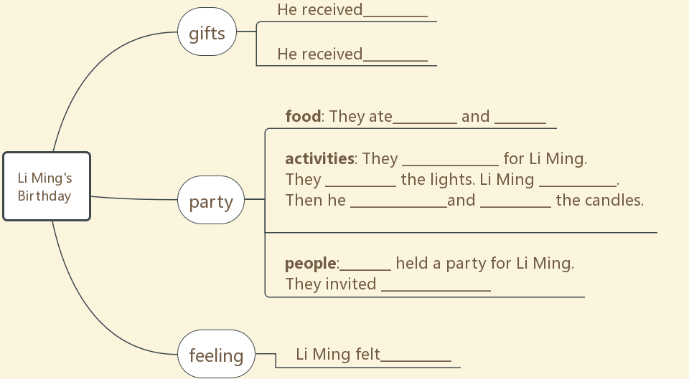
IV. 探究未知
Task2: Think about your birthday. How did you celebrate your birthday? Write a short passage as a group about it and read it to the class. The following questions may help you.
Tips:1.When is your birthday? 2.Who did you invited? 3.What kind of gift did you receive? 4.What did you eat? 5. What did you do? 6. Who do you want to thank?
Try to use these sentences: I will think of you when I wear it.
I laughed and laughed when I saw it.
When it was time for dessert, she turned off the lights.
____________________________________________________________________________________________________________________________________________________________________________________________________________ ____________________________________________________________________________________________________________________________________________________________________________________________________________

背诵目录
单词： postman /'pəʊs(t)mən/ n.邮递员；邮差 balloon /bə'lu:n/ n.气球
- deep /di:p/ n.深的 blow(blew/blown) /bləʊ/ v.吹
短语： 1. in fashion 时尚；流行
- turn off 关掉
- make a wish许愿
- blow out吹熄；吹灭
句型：
1. I will think of you when I wear it.
I laughed and laughed when I saw it.
When it was time for dessert, she turned off the lights.
2.描述庆祝生日过程
My mother and father held a party for my birthday. They invited... We ate noodles. Eating long noodles means you will have a long life. My mother bought a birthday cake. We turned off the lights and lit the candles on it. I made a wish. Then I took a deep breath and blew out the candles. I received a birthday gift, it was a...

